*Blending*

**FAMILIES**

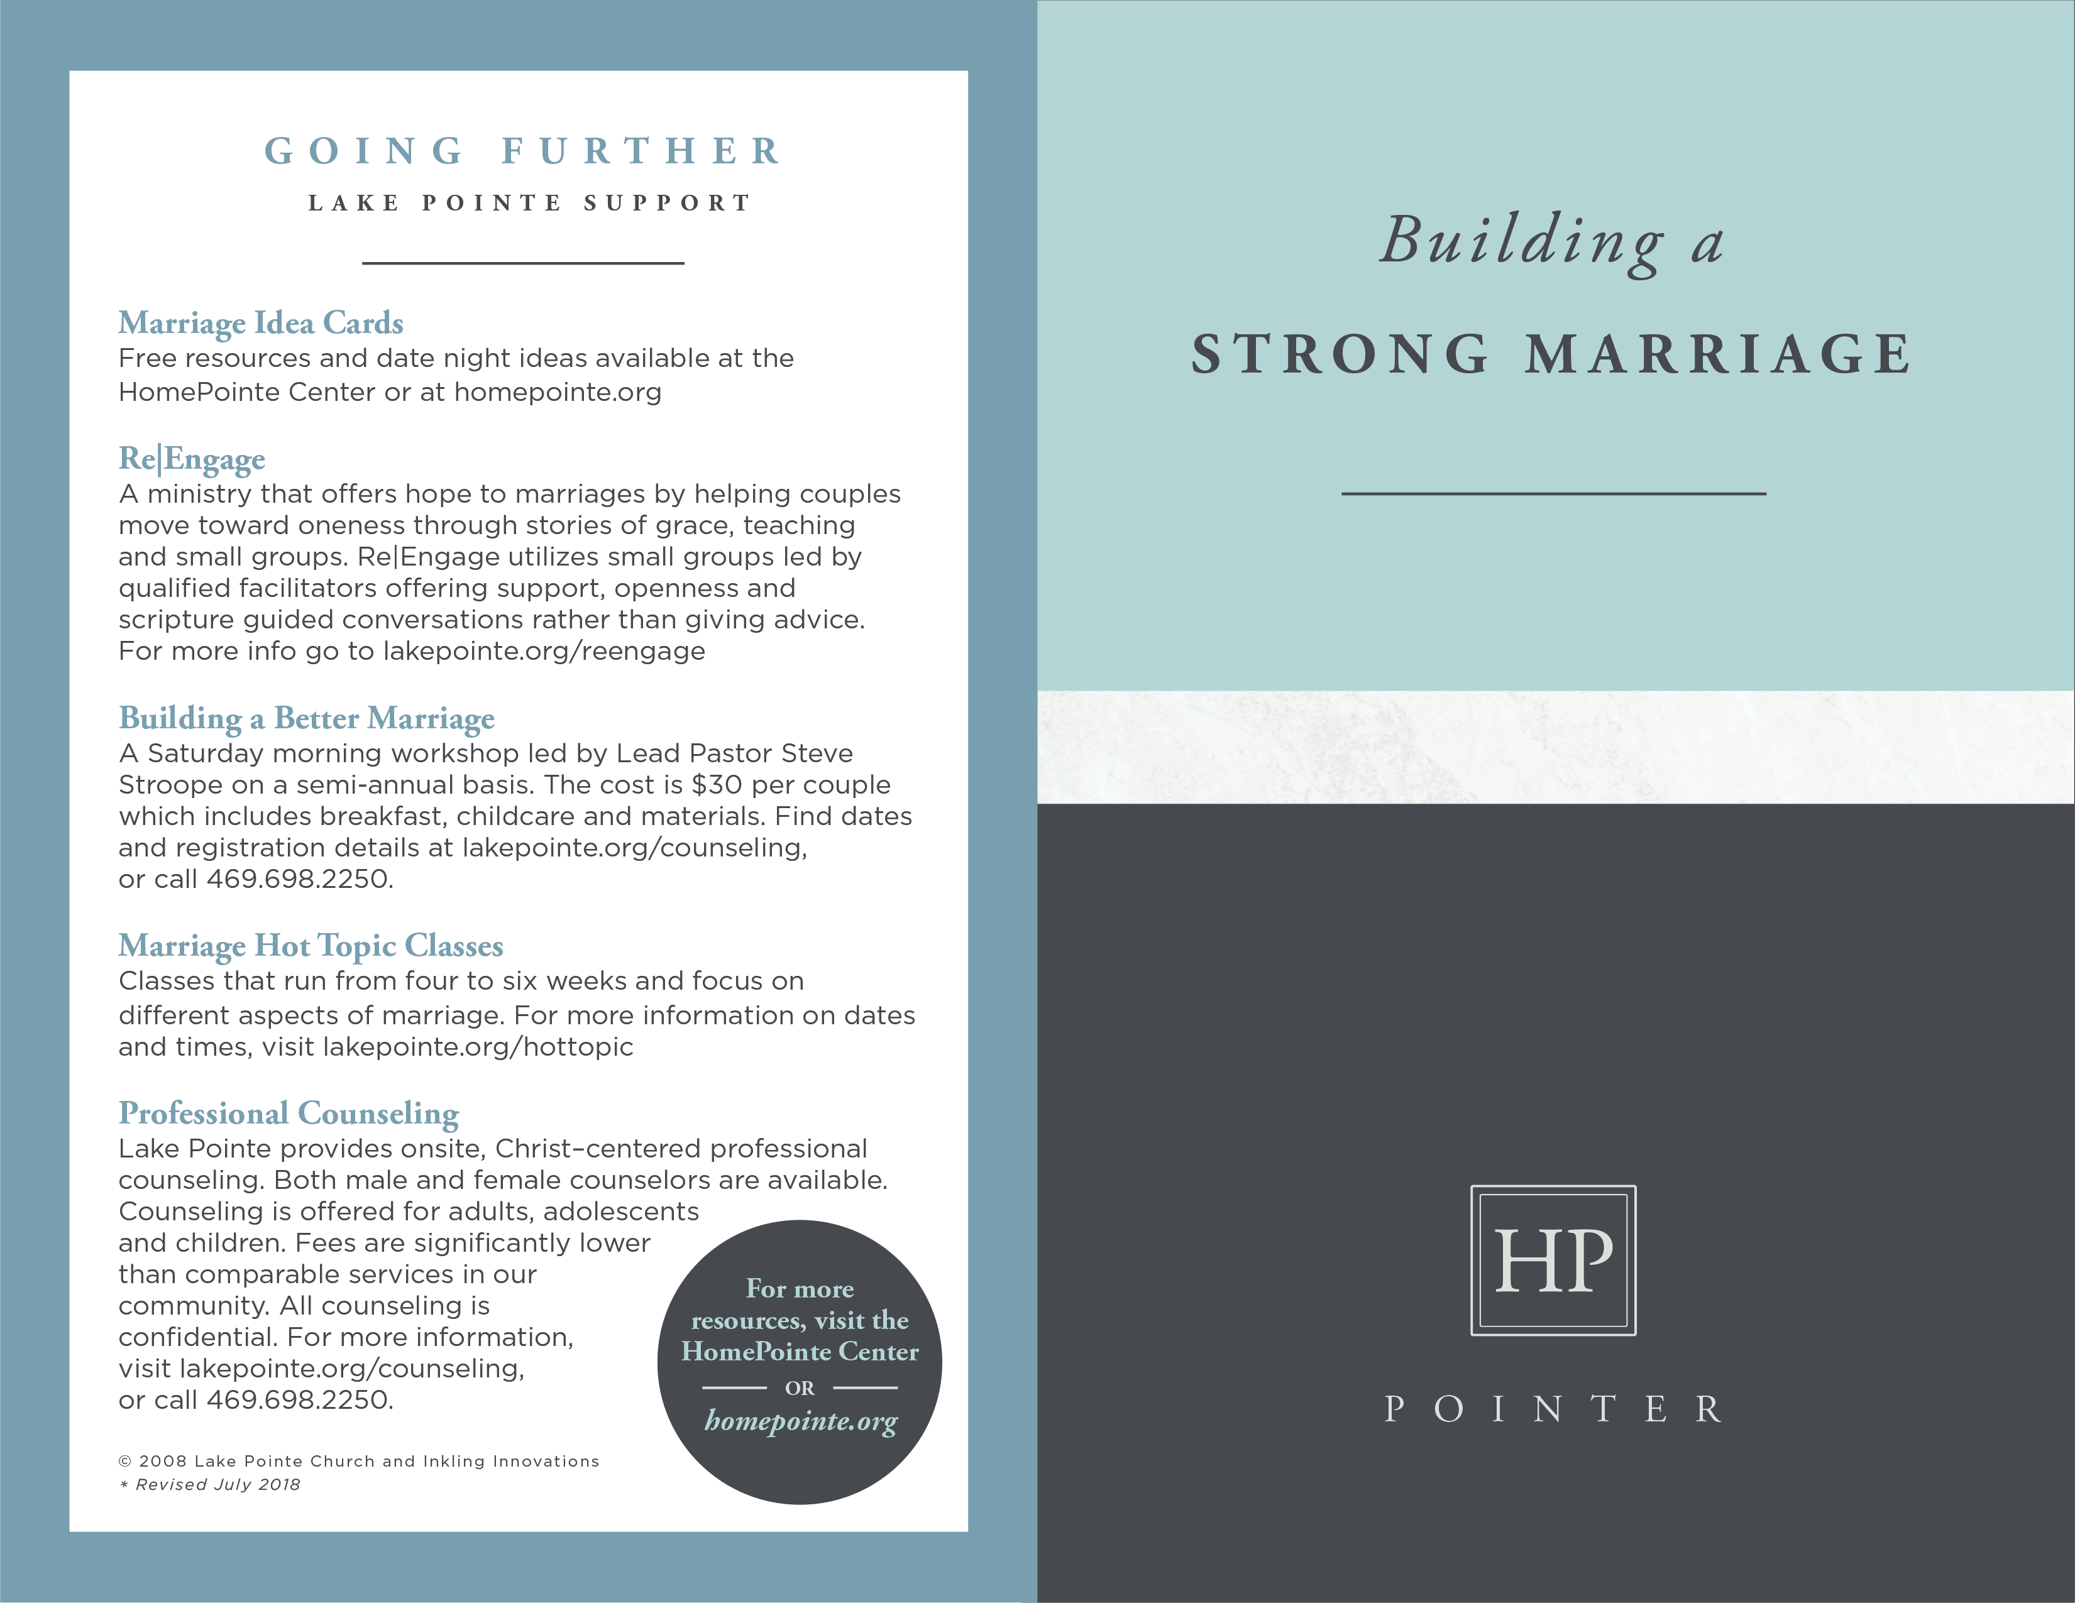

**GOING FURTHER**

**RESOURCES**

___________________

***The Smart Step-Family: The Seven Steps to a Healthy Family*** by Ron Deal

Provides a solid Biblical framework and practical guidance

for helping stepfamilies work to honor God.

***Saving Your Second Marriage Before It Starts*** by Les & Leslie Parrott

Prepares couples for what lies ahead and enables them to tackle the

challenges with faith, perseverance, and hope.

***Familylife.com/blended***

Provides biblically based resources that help prevent re-divorce, strengthen

step-families, and help break the generational cycle of divorce.

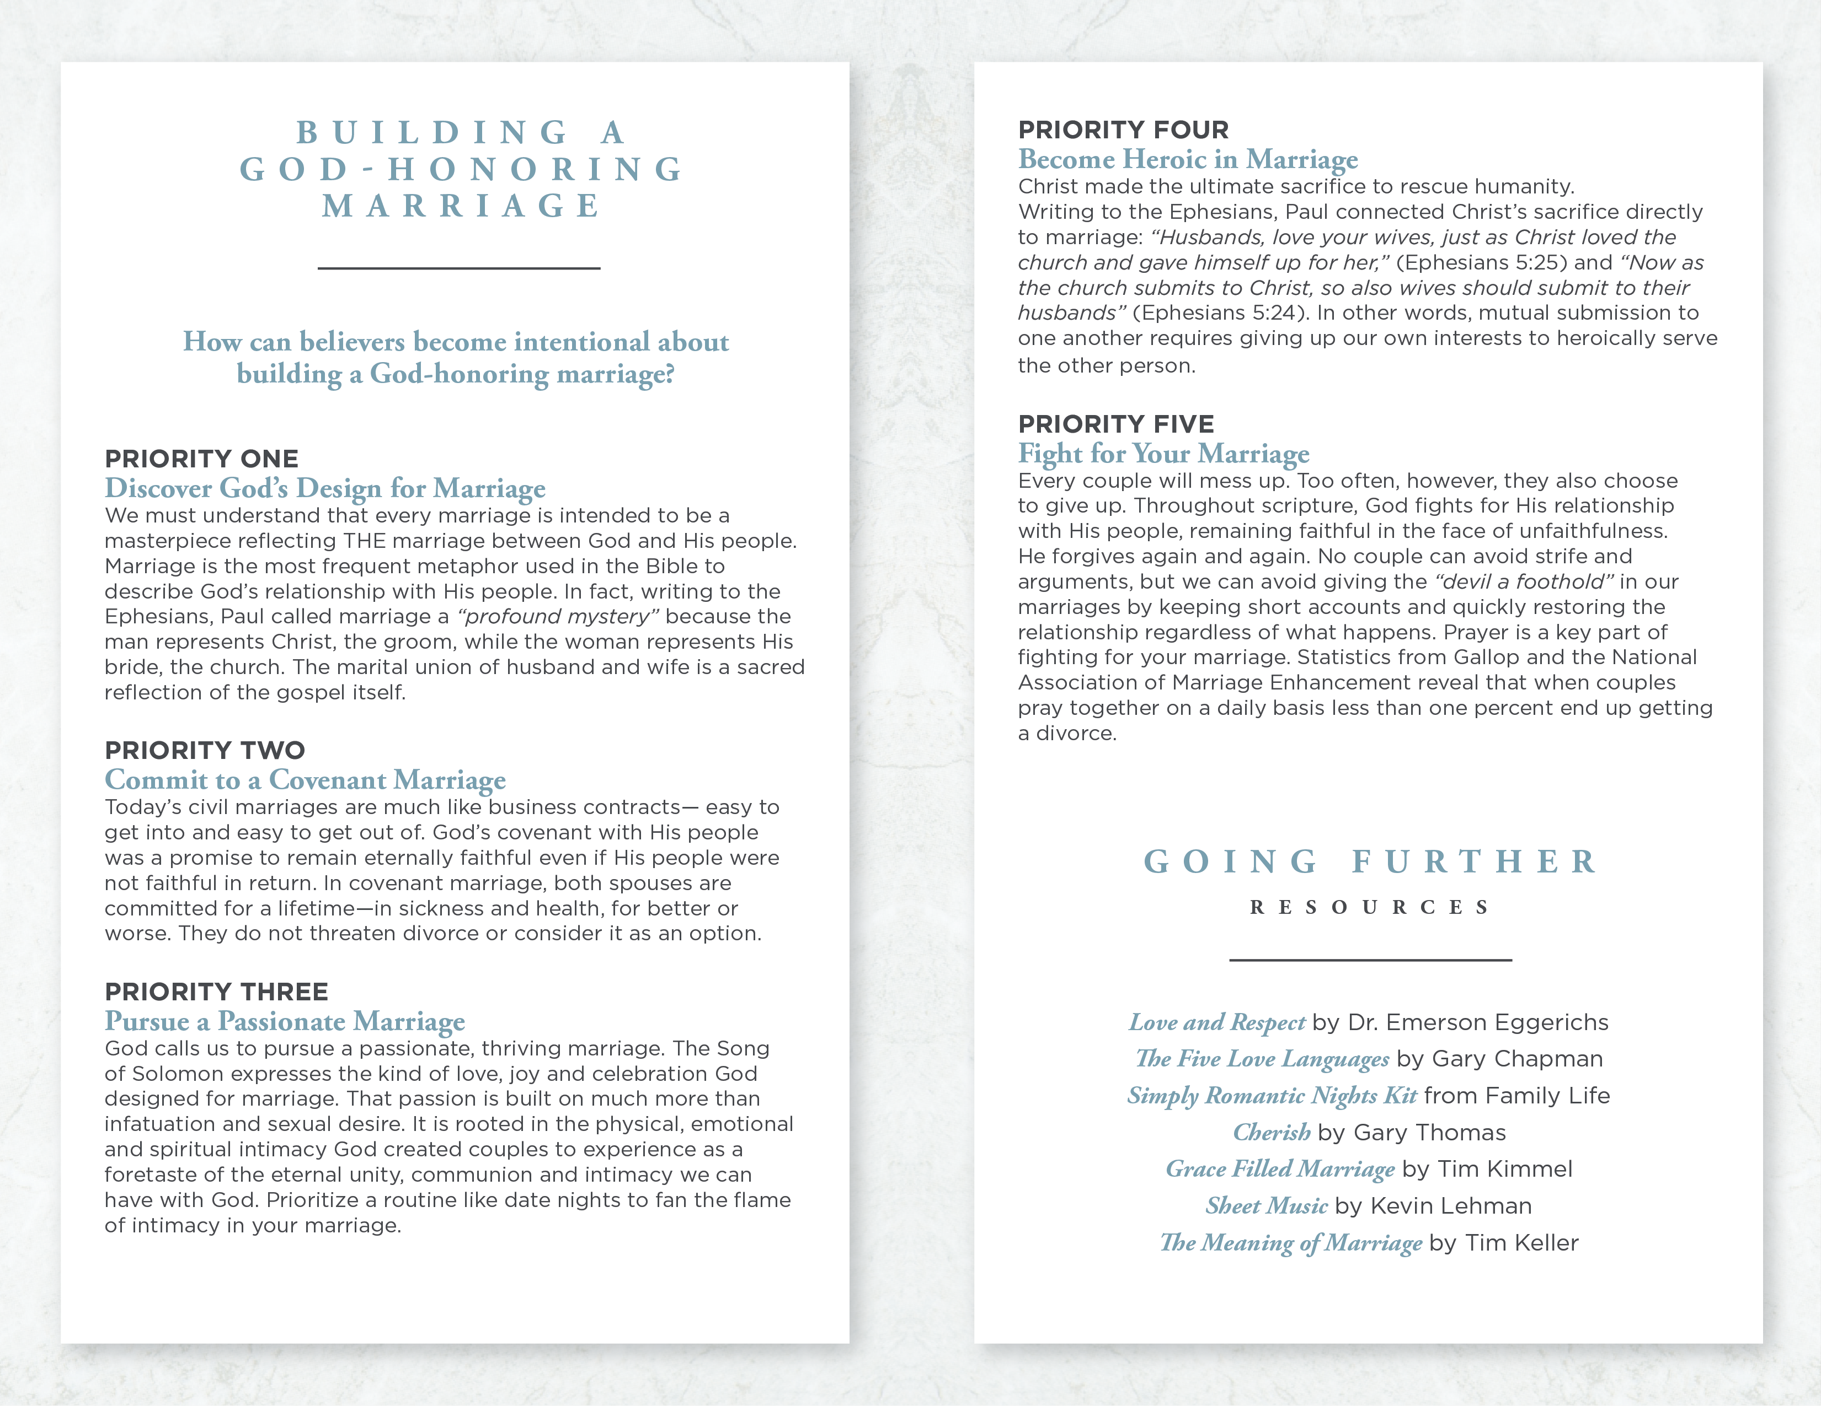

**SUCCESSFULLY**

**BLENDING**

**FAMILIES**

___________________

***“Did you ever notice how The Brady Bunch got just about***

***all their step family challenges worked out in the first***

***episode?”* asks Ron Deal of *Successful Stepfamilies*.**

**Ron works alongside a growing number of ministries coaching families on Biblical principles to overcome the challenges of blending their families. Any home in which at least one spouse brings children from a prior relationship knows that it is much harder in real life than it was for**

**the Brady family. That’s why blended families need**

**to add an extra measure of intentionality,**

**including several important steps.**

**STEP ONE**

**Recognize a Higher Calling**

Even though blended families are becoming a more common family structure, making them work well remains a real challenge due to the extra logistics and emotional landmines that are part of merging two homes into one. The additional challenges you face in building a strong marriage and family make following Jesus’ example of laying down your life for others even more essential. That calling is clear in the letter Paul wrote to the Philippians:

*Each of you should look not only to your own*

*interests, but also to the interests of others. Your attitude*

*should be the same as that of Christ Jesus: Who, being in very*

*nature God, did not consider equality with God something to be*

*grasped, but made himself nothing, taking the very nature of a*

*servant, being made in human likeness (Philippians 2:4-7).*

Regardless of your circumstances - whether your new family was the result of a death, divorce, or some painful choices - you are called to lay aside your own interests in order to serve those God has placed in your home (Matthew 16:24-25).

**STEP TWO**

**Focus on the Children**

Various family experts stress that strong families start with strong marriages - as the relational health of the couple goes, so goes that of the children. That’s not necessarily the priority, however, with blended families. Ron Deal has found that couples must first invest in the children they’ve brought together in order to be able to experience a growing marriage.

This is especially true in the area of establishing authority. Children need parents to exercise legitimate authority over them. Unfortunately, children often see the authority exercised by non-biological parents as illegitimate. When this becomes evident, stepparents are tempted to either bulldoze their way to authority or just leave most of the work to the biological parent. Either of these options leads to greater stress. Non-biological parents still need to exercise an appropriate measure of authority - but they do need to earn respect, not just demand it. Ask the Lord to give you an extra measure of patience and humility in dealing with stepchildren – especially when you know they have experienced the pain of divorcing parents or the grief of a deceased mom or dad which can cause long-term emotional trauma.

**STEP THREE**

**Allow God to Redeem Your Story**

In Joel 2:25, God says, “I will repay you for the years the locusts have eaten.” Every stepfamily brings with it the hope for a redeemed life story - the hope that difficult chapters of the past can be followed by better days. Stepfamilies quickly learn that better days don’t appear magically. As they submit to God’s calling and trust His ability to write their stories, however, they find He is still able to make all things new.

© 2008 Inkling Innovations; Revised: 31-Jul-2018