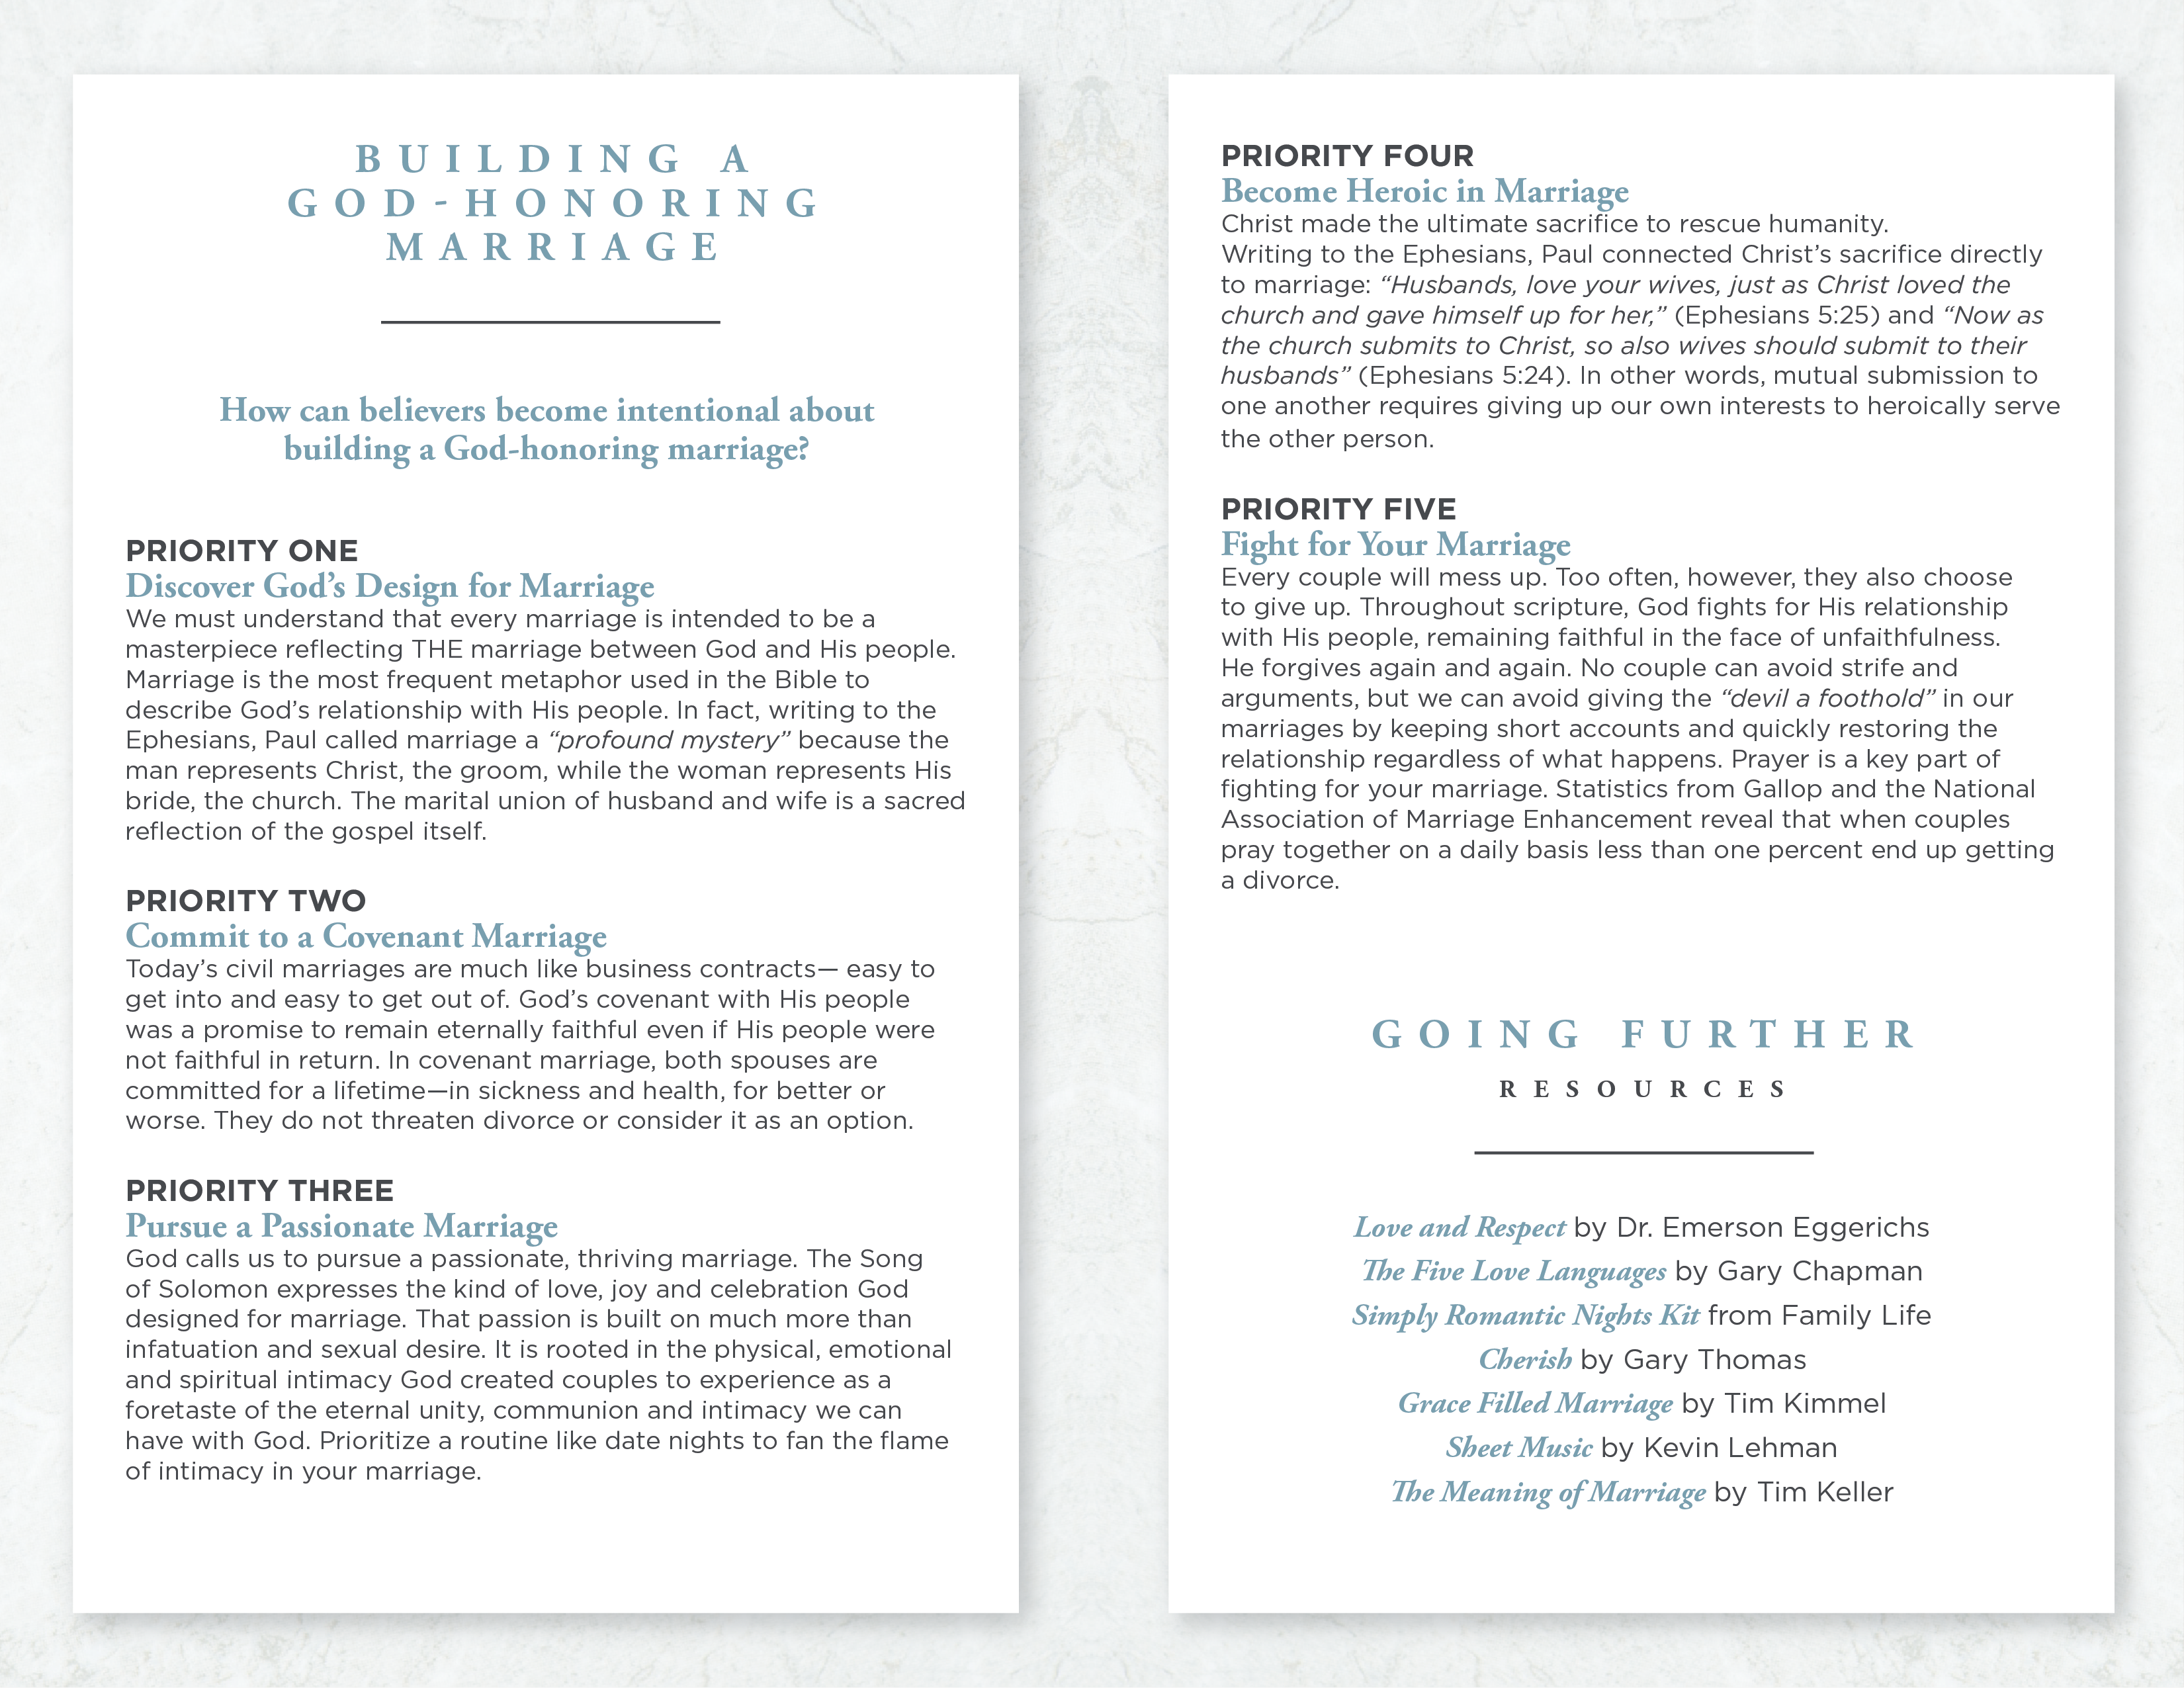

**BUILDING A**

**GOD-HONORING**

**MARRIAGE**

___________________

**How can believers become intentional about**

**building a God-honoring marriage?**

**PRIORITY ONE**

**Discover God’s Design for Marriage**

We must understand that every marriage is intended to be a masterpiece reflecting THE marriage between God and His people. Marriage is the most frequent metaphor used in the Bible to describe God’s relationship with His people. In fact, writing to the Ephesians, Paul called marriage a “profound mystery” because the man represents Christ, the groom, while the woman represents His bride, the church. The marital union of husband and wife is a sacred reflection of the gospel itself.

**PRIORITY TWO**

**Commit to a Covenant Marriage**

Today’s civil marriages are much like business contracts—easy to get into and easy to get out of. God’s covenant with His people was a promise to remain eternally faithful even if His people were not faithful in return. In covenant marriage, both spouses are committed for a lifetime—in sickness and health, for better or worse. They do not threaten divorce or consider it as an option.

**PRIORITY THREE**

**Pursue a Passionate Marriage**

God calls us to pursue a passionate, thriving marriage. The Song of Solomon expresses the kind of love, joy and celebration God designed for marriage. That passion is built on much more than infatuation and sexual desire. It is rooted in the physical, emotional and spiritual intimacy God created couples to experience as a foretaste of the eternal unity, communion and intimacy we can have with God. Prioritize a routine like date nights to fan the flame of intimacy in your marriage.

## **PRIORITY FOUR**

## **Become Heroic in Marriage**

Christ made the ultimate sacrifice to rescue humanity. Writing to the Ephesians, Paul connected Christ’s sacrifice directly to marriage: “Husbands, love your wives, just as Christ loved the church and gave himself up for her” (Ephesians 5:25) and “Now as the church submits to Christ, so also wives should submit to their husbands” (Ephesians 5:24). In other words, mutual submission to one another requires giving up our own interests to heroically serve the other person.

## **PRIORITY FIVE**

## **Fight for Your Marriage**

Every couple will mess up. Too often, however, they also choose to give up. Throughout scripture, God fights for His relationship with His people, remaining faithful in the face of unfaithfulness. He forgives again and again. No couple can avoid strife and arguments, but we can avoid giving the “devil a foothold” in our marriages by keeping short accounts and quickly restoring the relationship regardless of what happens. Prayer is a key part of fighting for your marriage. Statistics from Gallop and the National Association of Marriage Enhancement reveal that when couples pray together on a daily basis less than one percent would end up getting a divorce.

© 2008 Inkling Innovations

**GOING FURTHER**

**RESOURCES**

___________________

***Lovology: God. Love. Marriage. Sex. And the Never-Ending Story of Male and Female*** by John Mark Comer

Gives a biblical vision for sexual intimacy and marriage and tackles difficult questions related to human sexuality.

***Love and Respect*** by Dr. Emerson Eggerichs

Helps couples appreciate and meet their mate’s greatest need.

***The Five Love Languages*** by Gary Chapman

Helps couples understanding and speak their mate’s “love language.”

***Have a New Sex Life by Friday*** by Kevin Leman

Encourages married couples to pursue the joys and pleasures of sexual intimacy.