**A DIFFICULT**

**MARRIAGE**

*Finding Hope and Help*

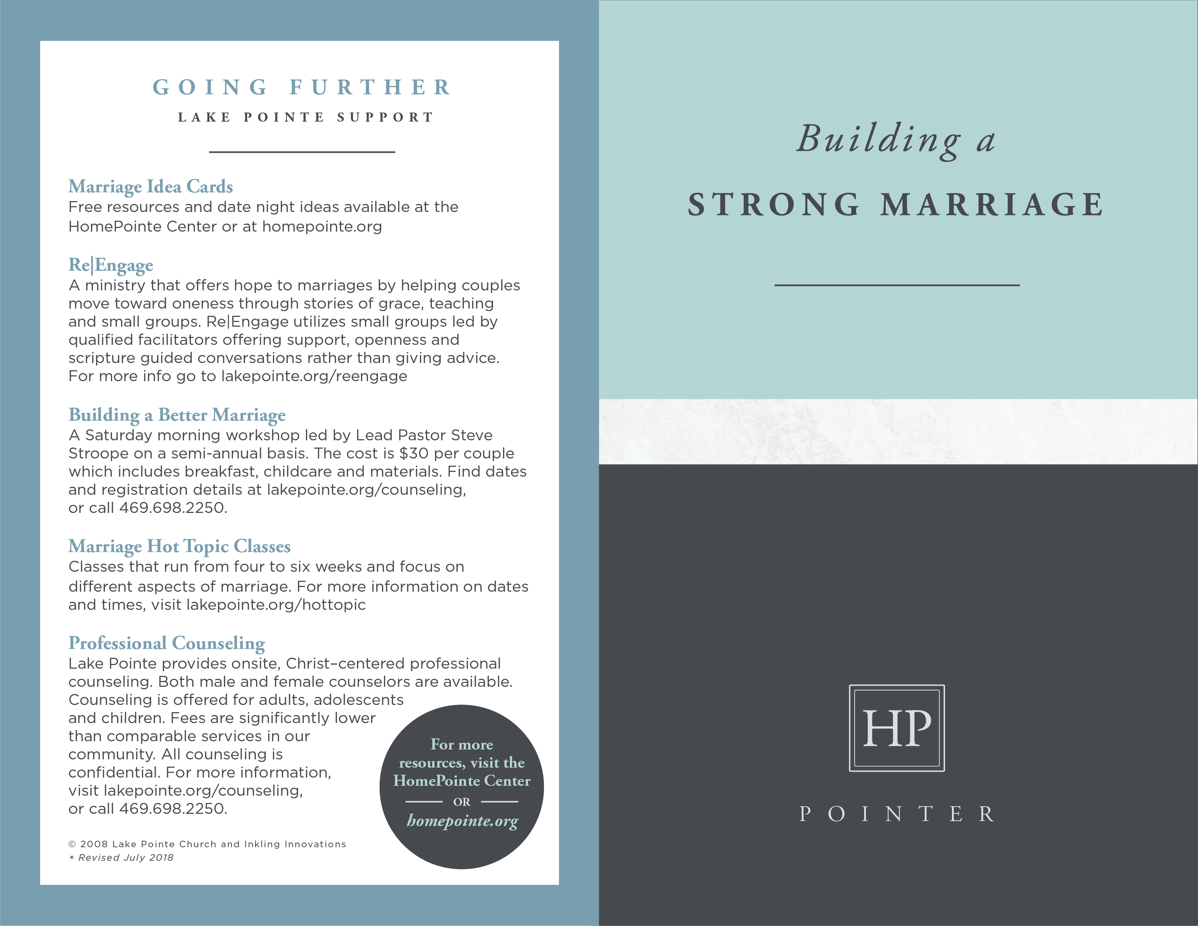

**GOING FURTHER**

**RESOURCES**

___________________

***Love and Respect*** by Dr. Emerson Eggerichs

Helps couples escape the “crazy cycle” of marital conflict by

understanding one another’s greatest need.

***Breaking the Cycle of Divorce*** by Dr. John Trent

Helps those raised in a divorced family avoid the same fate in their own marriage.

***Boundaries in Marriage*** by Dr. Henry Cloud and Dr. John Townsend

Helps individuals establish healthy boundaries when married to a difficult spouse.

***Love Must be Tough*** by Dr. James Dobson

Helps victims of adultery or abuse confront their spouse’s

wrong choices and behaviors.

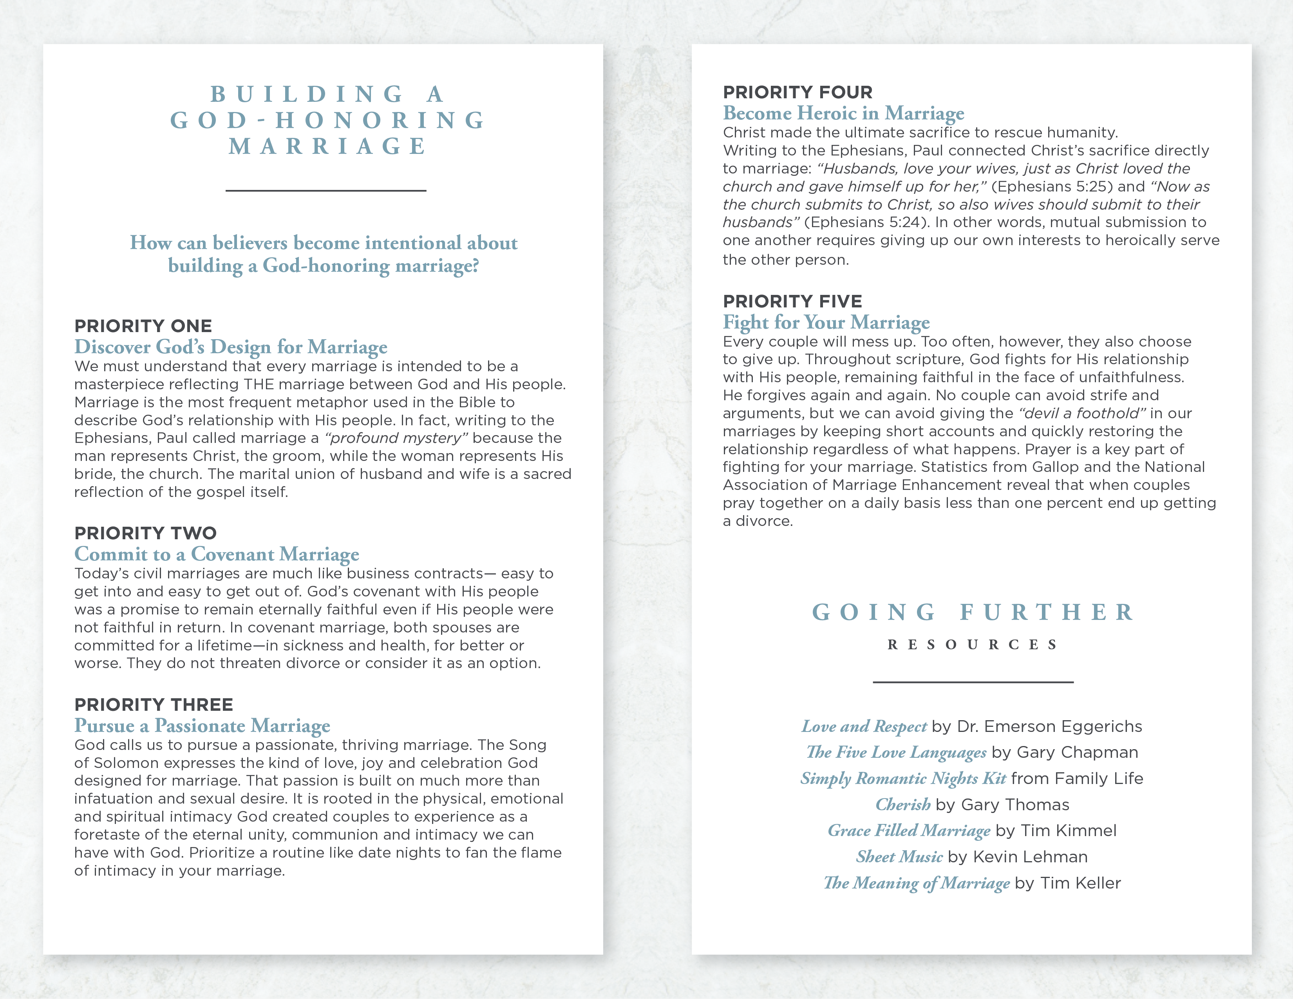

**HOPE FOR A**

**DIFFICULT OR**

**ABUSIVE MARRIAGE**

___________________

Those who marry will have troubles. That’s what Paul told the Corinthian church (1 Corinthians 7:28). Even the best couples can struggle to protect their marriage vows. But what happens when marriage troubles become unbearable? Is there a point at which couples should end a bad marriage? Or is there hope for something better? Walk through the following steps as you prayerfully evaluate your situation.

**STEP ONE**

**Discern Minor from Major Trouble**

Unfortunately, many marriages end today over troubles that could have been overcome. University of Texas researcher Norval Glenn has found that divorces today are often blamed on problems such as “lack of commitment,” “too much conflict and arguing,” “unrealistic expectations” and “lack of preparation.” These are problems that both husband and wife can and should work to overcome. Despite what friends, family or popular culture might say, these issues are no reason to end a marriage - especially in light of the serious long-term impact of divorce on your children.

In their book, *The Case for Marriage*, Maggie Gallagher and Linda Waite explain that couples who think their only options are to either divorce or be miserable often find things getting better if they’ll just stick it out. In fact, almost eighty percent of husbands and wives who were very unhappy in their marriage yet stayed together described themselves as very happy just five years later!

**STEP TWO**

**Anticipate the Hope After the Trouble**

Major trouble occurs when someone either abuses or abandons their role in a marriage - when they break faith with their spouse and violate their vows. While God hates divorce (Malachi 2:16), He permits it for marital unfaithfulness (Matthew 19:1-8). In God’s grace, He allows, but does not command, men and women whose spouses have been unfaithful to start over.

However, God is in the business of helping couples redeem what many would see as a hopeless situation. “Even marriages that have faced one or more of the big ‘A’s - abuse, affairs or addictions - can be saved,” says Mitch Temple, a licensed marriage counselor. Temple has led numerous intensive counseling sessions with couples that faced these major challenges and even though they had Biblical grounds for divorce they found a way to save their marriages.

**STEP THREE**

**If Needed, Protect Yourself and Children**

If your relationship is marked by physical or severe emotional abuse, you may find yourself confused, frightened and unsure about what to do. The most important thing you can do right now is take steps to protect yourself and your children from harm. Even if you want to save your marriage, you should not risk the safety of your children or yourself. A period of structured and therapeutic separation may be needed and can make it possible for you to get the help your marriage needs while making your family less vulnerable.

**STEP FOUR**

**Seek Guidance – Don’t Go It Alone**

Whatever situation you’re in, don’t struggle through a difficult marriage alone. You need the Lord like never before. He is eager to hear your prayers and walk this journey with you. Whether you are praying together or praying for your marriage alone, the power of prayer can make all the difference. You also need the church body like never before - for perspective and advice, counseling and encouragement, and hope for God’s redemption. Take advantage of the *Going Further* resources and services of this church.

© 2008 Inkling Innovations; Revised: 31-Jul-2018