**A DIFFICULT**

**TEEN**

*Navigating Rebellion*

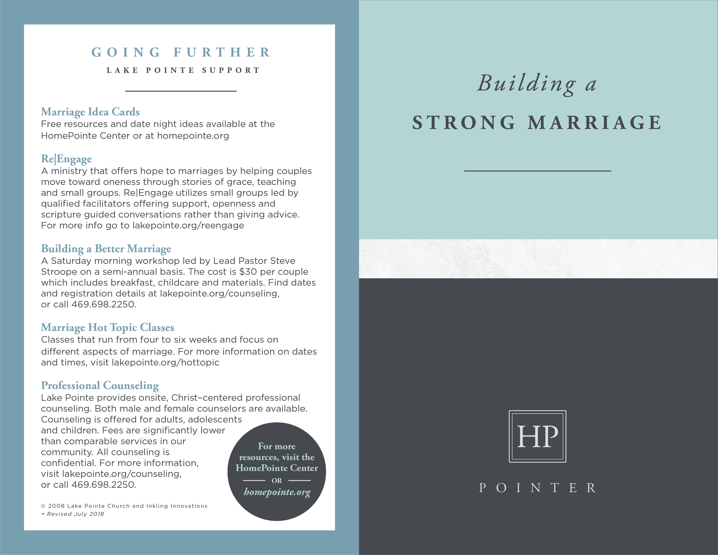

**GOING FURTHER**

**RESOURCES**

___________________

***Boundaries with Teens: When to Say Yes, How to Say No***

by Dr. John Townsend

Will help you establish wise and loving limits that make a positive difference

in your adolescent, in the rest of your family, and in you.

***Yes, Your Teen Is Crazy: Loving Your Kid Without Losing Your Mind***

by Michael Bradley

Gives parents the training and skills they need to transform their teenage children into strong, confident, productive adults. (Disclaimer: This book contains

some strong language describing difficult situations.)

***Have a New Teenager by Friday*** by Kevin Leman

Helps parents establish healthy boundaries and workable guidelines,

navigate the critical years with confidence, and become the

major difference maker in their teenager's life.

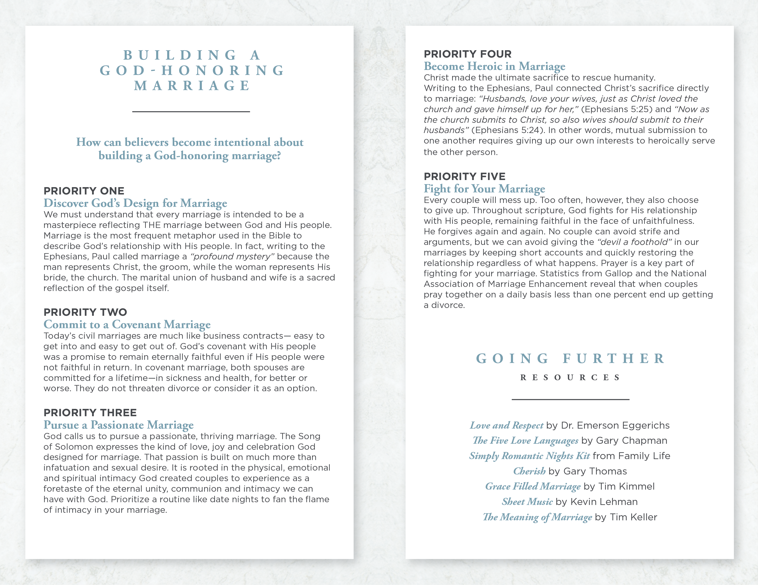

**DEALING WITH A**

**REBELLIOUS TEEN**

___________________

There is little in life that creates more anxiety than having a teenager who seems out of control. Experiencing emotional outbursts, being lied to, or staying up at night worrying about their safety can greatly damage your relationship with your teen. You may have tried different approaches to help them - being tough one day and then trying to show mercy the next - but nothing really seems to make a difference. Watching your teen continue to make bad choices can leave you torn between wanting them to just learn the hard way and being afraid of what they might do in a moment of irresponsibility. Focus this time on praying; seeking God for wisdom and asking for His protection and to draw your teen closer to Him and you.

**Discover steps you can take now**

**to best help your child…**

**STEP ONE**

**Assess Your Relationship**

As teen expert Josh McDowell has said, “Rules without relationship leads to rebellion.” Considering that your teen’s emotions and behavior are being affected by a surge of changing hormones, it’s vital for you to maintain as strong a relationship as possible in the midst of whatever they may be going through. If you have a solid relational foundation, you can build from there. Like the father in the story of the prodigal son (Luke 15:11-32), you can hope that your unconditional love and forgiveness will ultimately draw your teen back.  Ask yourself several questions to evaluate the status of your relationship, such as…

* **Is our relationship generally healthy with a few bumps, or generally unhealthy with rare moments of connection?**
* **Am I spending time with my teen doing things we enjoy together to create a solid foundation for when tensions occur?**
* **Does my child feel deeply loved or heavily criticized? (1 Peter 4:8)**
* **Are my spouse and I on the same page – or is there increased tension because we are not?**
* **Has the relationship deteriorated to the point we need pastoral or professional guidance?**

What if the relationship is weak? Maybe you’ve been relationally disconnected for a long time, or maybe your teen is a stepchild who has never really accepted you as his or her parent. Even under these and similar circumstances, you earn respect by building relationship. Making yourself available, listening, and trying to understand increase your ability to have influence. Dr. James Dobson stresses the value of routine family connections as a way to cultivate relationship. He cites research showing the positive difference parents make when they are available for their teens in the morning, after school, at dinnertime, and at bedtime. If your current routine is making these connections difficult, it may be time for a change.

**STEP TWO**

**Be the Parent**

Some parents interpret the need for relationship as a call to be good friends to their teens, but you need to be the parent—the one who brings stability and structure to the child’s life by setting boundaries and expectations. Showing that kind of authority can be difficult for some, but it is an essential role of parenting. It can also be challenging to direct your teen in a way that doesn’t exasperate him or her (Ephesians 6:4) when you feel disrespected. As the adult, you need to sacrifice your hurt feelings and anger to do what’s best for your teen. You are called as the parent to lovingly direct your teen through the challenges leading to adulthood. Ephesians 4:15 directs us to “speak the truth in love.” Ask God to show you when it’s important to be tough and when you need to lead with gentleness and compassionate love.

**STEP THREE**

**If Serious – Seek Professional Help**

In this church body, you are surrounded by parents who have raised teenagers; many of whom faced challenges similar to yours. There’s no reason to be embarrassed by the challenges you have or to strive to keep the veneer of a perfect family. You need the support and wisdom of those who have been where you are. Do you find yourself asking any of these questions?

* **How can I find out if my teen is using drugs or alcohol?**
* **Is my teen having sex, and if so, what should I do?**
* **Why does my teen seem so depressed?**
* **I think my teen is looking at online pornography. What do I do?**

Problems such as alcohol or drug use, pornography addiction, sexual experimentation, severe depression and other challenges may fall beyond your understanding. Seek the help of counselors and experts who can bring Biblical wisdom along with professional understanding of teens and risky behavior.

© 2008 Inkling Innovations; Revised: 31-Jul-2018