*The*

**EMPTY NEST**

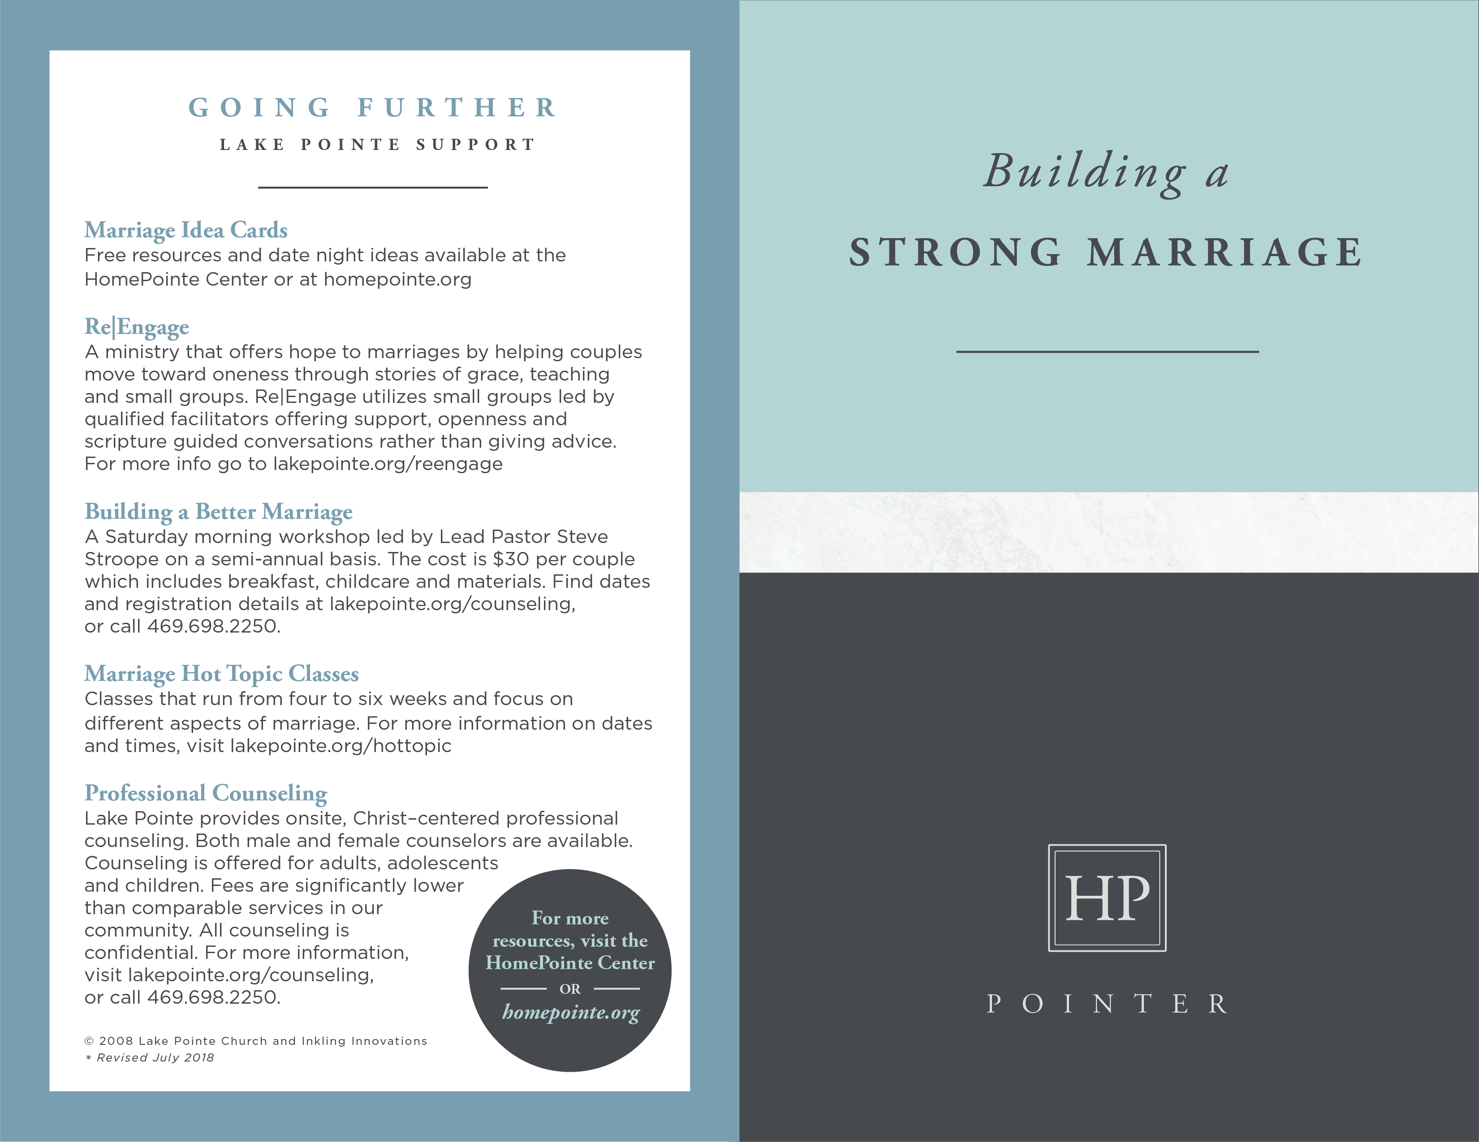

**GOING FURTHER**

**RESOURCES**

___________________

***Half Time*** by Bob Buford

Shows how you can make the second half of your life even more rewarding than the first.

***Second Half of Marriage*** by David and Claudia Arp

Reveals eight marital challenges every long-term marriage faces, and they offer strategies and exercises for meeting each of them. This book will challenge you to create a vision for the rest of your life together - and inspire you to make that vision a reality.

***Married and Still Loving It: The Joys and Challenges of the Second Half***

by Gary Chapman and Harold Myra

Offers wise counsel and practical insight on making your marriage thrive during the later years and will inspire and equip you to embrace the adventures

yet ahead, hand in hand with the one you love.

***Barbara and Susan’s Guide to the Empty Nest: Discovering New Purpose, Passion, and Your Next Great Adventure*** by Barbara Rainey and Susan Yates

Offers practical advice and biblical guidance, along with inspiring personal stories of women who have discovered how to live a meaningful life during the "second half” to help you work out how to flourish and thrive in your own empty nests.

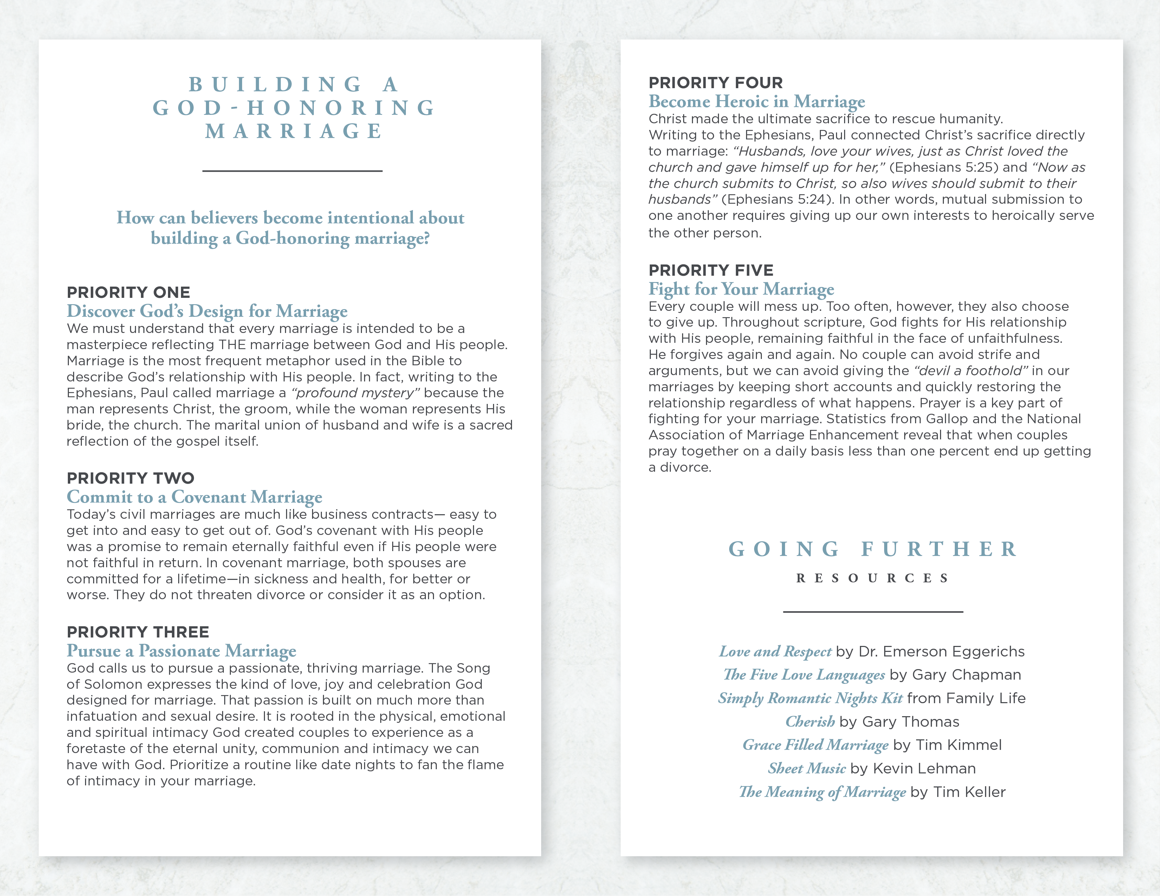

**THE EMPTY**

**NEST YEARS**

___________________

**Achieving the long-term goal of raising and launching children is one of those milestones in life that can lead to surprising emotions. One day you might feel relieved to catch your breath after such an intense marathon and then the next day you miss the busyness - especially the ever-present relationships that went with it. Whether you are approaching, just hitting or deep into the empty nest season you are likely experiencing a range of feelings that can leave you asking yourself “What next?”, this would be a great time to take steps toward rediscovery in your life.**

**STEP ONE**

**Rediscover Your Mission**

A major segment of your life up to this point has been committed to serving and guiding your children. That faithful and daily focus on those within your home has been preparing you for broader service. In 1 Timothy 3:5 Paul asks the question, “If anyone does not know how to manage his own family, how can he take care of God's church?” Another way to see that passage is that those who have managed their families have learned a couple of things about how to care for God’s church - how to love, forgive, guide, lead and encourage. Such characteristics developed in the last season, as well as the additional time and resources that often come with an empty nest, can equip you for a whole new world of opportunities to fulfill your mission during this exciting season of life.

**STEP TWO**

**Rediscover Your Marriage**

Some marriages don’t last until the empty nest years either because of death or divorce. Married couples may feel like the tsunami of kids that swept in and out has left you needing to rediscover the person to whom you said “I do” so long ago. Proverbs 5:18-19 says, “May your fountain be blessed, and may you rejoice in the wife of your youth.” After this intense stretch of parenting, how can you find fresh ways to rejoice in the marriage

of your youth and to “be ever captivated” by your spouse? You may just need to re-introduce yourself and start rediscovering some of your earlier passions and dreams.

**STEP THREE**

**Rediscover Your Children**

During earlier parenting stages, you had some fairly clear lines of authority and control, especially when it came to your house rules. Those lines blur as your children become independent - even if they boomerang back home for a season. Now is the time when your influence is built upon strong relationship rather than direct control. Your efforts will focus on coaching your children into self-sufficiency, pursuing marriage and building families of their own. This season requires a lot of trust because “sideline coaching” is all you can offer rather than step-by-step direction. But this season also gives you a vantage point to see the time and effort you’ve invested into your children in a different light - especially as they begin to take ownership of the values you’ve tried to instill (Psalm 78:3-7) and watch them discover God’s plan for their lives. Best of all you can begin to enjoy adult to adult friendship with your children which will bring new joys and rewards.

© 2008 Inkling Innovations; Revised: 31-Jul-2018