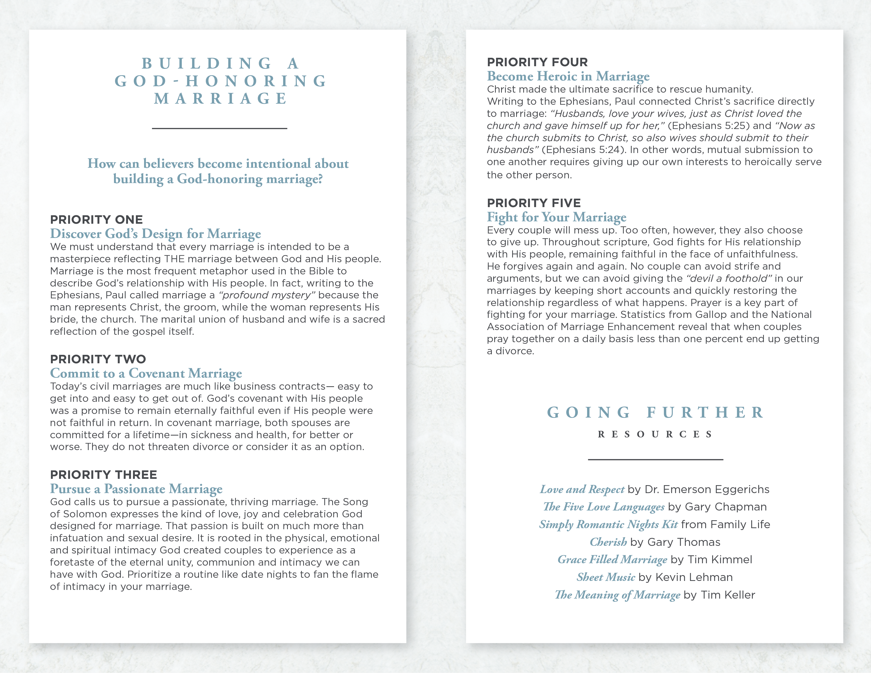

**GETTING READY**

**FOR MARRIAGE**

___________________

**Congratulations on this wonderful milestone. Few seasons in life are filled with as much joy and anticipation as the time spent preparing to get married.**

**You’ve probably heard it said that as you plan your wedding, you shouldn’t forget to plan your marriage. But it sounds so abstract to “*plan a marriage*” in the midst of the more tangible (and demanding) project of planning a wedding.**

**How do you do it?**

**STEP ONE**

**Learn from Others**

Research demonstrates the long-term value of making time now for marriage education classes or premarital counseling. Those efforts go even further when you supplement them by spending time with an older married couple whose relationship you admire.

**STEP TWO**

**Plan with Patience**

Couples often overlook the importance of using the wedding planning season as practical marriage preparation. You can intentionally set the tone for your marriage by the values you live out in planning your big day. The transformational process of “becoming one” can occur in everything from how you assemble your guest list to how you determine a honeymoon destination. Consider beginning the habit of a weekly date night or times of intentional connection to set a foundation for your marriage.

**STEP THREE**

**Discover the Purpose of Marriage**

A wedding is bigger than you as an individual and even bigger than you both as a couple. Ephesians 5 describes a couple laying down their lives for one another and becoming one as an icon of God’s sacrificial love for His church.

That’s the counter-cultural call of Christian marriage. Consider reading one of the books suggested in the Going Further section together to deepen your understanding of the larger purpose of your union.

**STEP FOUR**

**Create a Meaningful Event**

Our culture today can often put more emphasis on “the big day” than preparing for a lifetime together. That’s not to say big celebrations are out of order, but many risk making them so complex that they fail to honor God or the community they are uniting - both of which are the basis for a strong Christian marriage.

During this special time of engagement, be intentional to draw close to the Lord and to each other as you establish a firm foundation for your marriage.

© 2008 Inkling Innovations; Revised: 31-Jul-2018

**GOING FURTHER**

**RESOURCES**

___________________

***Before You Say “I Do”: A Marriage Preparation Manual for Couples***

by H. Norman Wright and Wes Roberts

***When Sinners Say “I Do”: Discovering the Power of the Gospel for Marriage***

by Dave Harvey

***Getting Ready for Marriage: A Practical Road Map for Your Journey Together* (Book & Workbook)**

by Jim Burns and Doug Fields

***Lovology: God. Love. Marriage. Sex. And the Never-Ending Story of Male and Female*** by John Mark Comer

Gives a biblical vision for sexual intimacy and marriage and tackles difficult questions related to human sexuality.