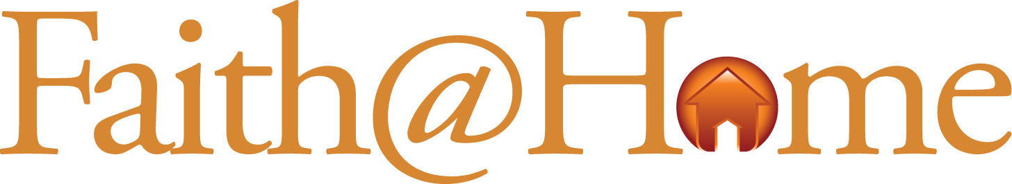

*Young Children*

***Going Once, Twice…***

**Best Use**

As a family night activity

**Nutritional Value**

Teaching kids how valuable they are to God

**Advance Preparation**

* Gather several items your kids have created such as drawings, notes, or a graded school paper.
* Have enough play or real money on hand to give each child an equal amount.
* Prepare an auction paddle for each child. (You can make these by stapling a piece of paper onto paint stir sticks. Write a number on each that represents the child such as their birth-order or month born.)
* Make sure you have a Bible on hand.

**Serve it up**

1. Invite the family to sit in a row of chairs in order to participate in an auction. Briefly explain the rules of your auction, such as “You can’t bid on your own items. This is about valuing the work of others.”
2. One at a time let each kid introduce one of his/her items to the group. Allow them to explain their creation and encourage them to drive up the price by crafting a good story about the item.
3. Let the bidding begin! (You may want to serve as auctioneer for the first several items to model the process before letting the kids take turns.)
4. When each item sells let the kids take turns being the cashier. This gives the added bonus of incorporating a math lesson into family night!
5. After auctioning all of the items sit back down and discuss how you determine the value of an object. For example, “You determine the value by how much someone is willing to pay for it. Some items went for a lot of money, while others did not.”
6. After establishing the basic principle read John 3:16, I John 3:16 and Romans 8:32 aloud together. Explain that God paid a very high price for us by sending His son to die in our place. Ask “What does that tell you about how valuable you are to God?”
7. Next, read Matthew 10:31 aloud together and then explain that Jesus tells us not to worry about stuff because we are so valuable to God.
8. End the auction by thanking God for loving us enough to pay the ultimate price for us.
9. Memorize the jingle together…

***For God’s Son to die***

***Our value must be high!***

*© 2010 Inkling Innovations & Lance Shumake*