*Young Children*

***Rolling In Money***

**Best Use**

As a family night activity with younger kids

**Nutritional Value**

Teaches the value of money and good stewardship

**Advance Preparation**

1. Go to the bank and withdraw as many one-dollar bills as you can up to $1000. (Don’t worry – you’ll return most of it the next day.)
2. Create an envelope titled “God’s Instructions for Money” with several notes containing Bible passages with instructions on how to use the money.

* Malachi 3:10 = Give 10% to God
* Proverbs 30:24-25 = Save 10% for the future
* Romans 13:8 = Pay your bills (List several pretend bills such as $500 for the house payment, $150 for food, $150 for the car, etc. Make sure the mock bills add up to almost the entire cash pile – leaving only a few dollars free.)

**Serve It Up**

Follow the instructions on the reverse side for an unforgettable experience.

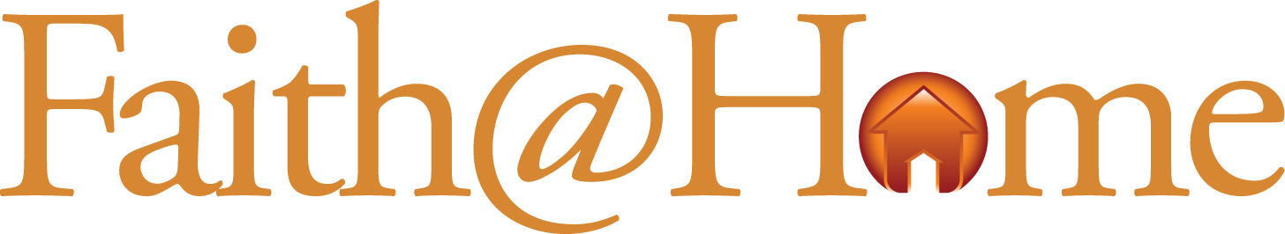

**Rolling In Money Family Night**

* **Step One:** Hide the pile of cash someplace in the house and invite the kids to find the secret treasure. When they find the money allow time for them to go nuts!
* **Step Two:** Invite the kids to count the treasure promising them they will be able to spend it on anything they want **AFTER** following God’s instructions for money.
* **Step Three**: Have the children count out enough one-dollar bills to meet each financial obligation described on the three notes – 10% for tithe, 10% for savings and enough for each of the “bills.”
* **Step Four**: Give each child the remaining cash to spend as they please. Needless to say, they will be a bit disappointed. But they will also better understand real-world expenses and our responsibilities as stewards of the money God gives.
* **Step Five**: End your time creating a “Stewardship Box” with three slots labeled “Give” and “Save” and “Spend” for the kids to use when they earn money or receive their allowance.

**Step Six:** Memorize the following jingle together…

*“Before you spend away – give, save and pay.”*

*© 2010 Inkling Innovations*