*Preparing*

**FOR BABY**

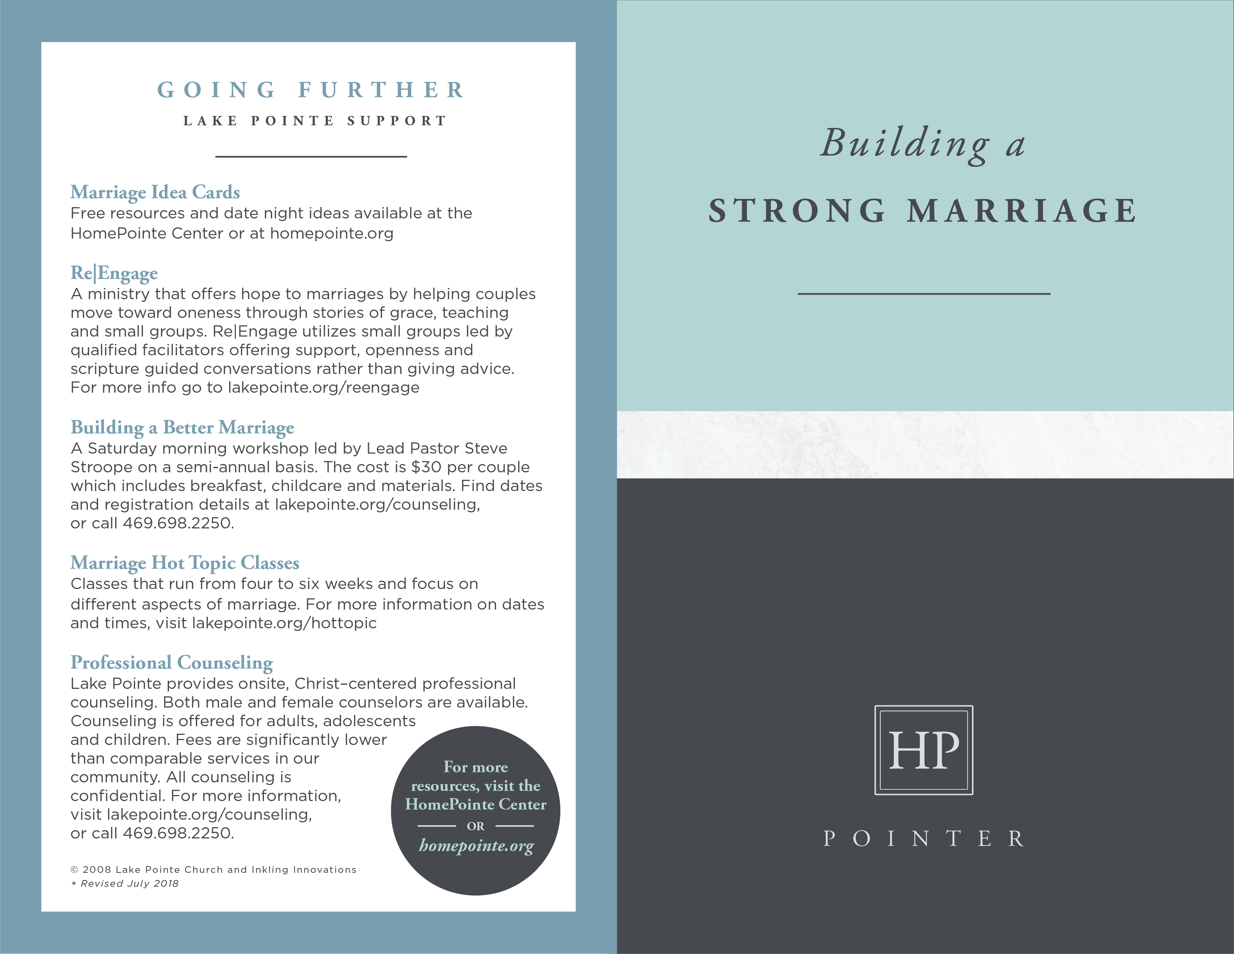

**GOING FURTHER**

**RESOURCES**

___________________

***Expectant Parents: Preparing Together for the Journey of Parenthood***

by Suzanne Hadley Gosselin

Provides helpful information for couples wanting to explore and prepare for the emotional, physical, and spiritual life changes that come with

the arrival of any new child into the family.

***The Christian Mama’s Guide to Having a Baby: Everything You Need to Know to Survive and Love Your Pregnancy*** by Erin MacPherson

Offers a detailed guide that takes you through each trimester with helpful tips, humorous accounts, and supportive spiritual advice--all with a girlfriend-to-girlfriend approach that helps moms feel comfortable as they navigate this life-changing time.

***And Baby Makes Three: The Six-Step Plan for Preserving Marital Intimacy and Rekindling Romance After Baby Arrives***

by John Gottman & Julie Schwartz Gottman

Helps new parents positively manage the strain that comes

along with their bundle of joy.

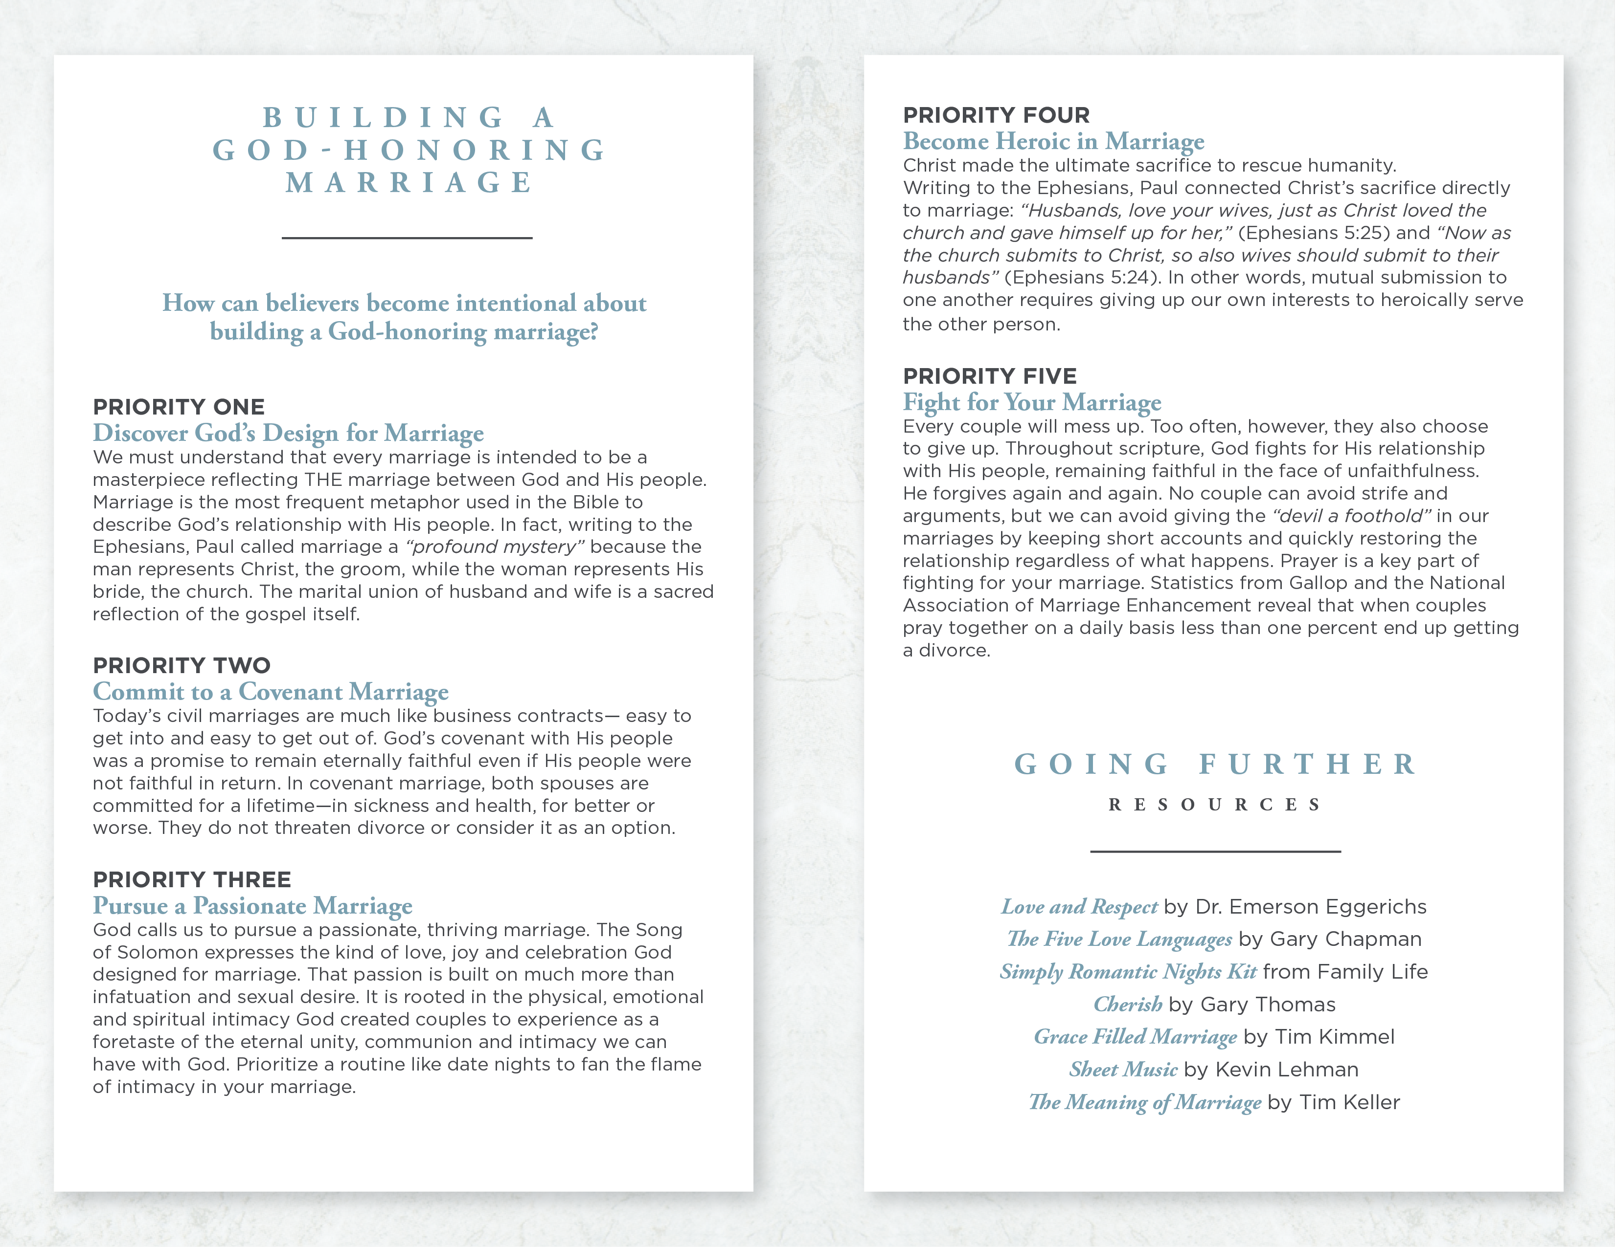

**PREPARING**

**FOR BABY’S**

**ARRIVAL**

___________________

Congratulations on the exciting stage of life. Whether you’ve recently had a new baby, are counting down to your due date or preparing to adopt, you’ve likely noticed that parenthood is an entirely different world. In the midst of all the joy and anticipation comes a whole new level of stretching and character development. You may be wondering if life will ever be the same. In many ways it won’t. It will become more fulfilling, more challenging and expensive than ever before as you pour your time, talents and resources into an investment that will yield amazing dividends! Those blessed with the gift of children are called to inspire and nurture the faith of the next generation as life’s greatest privilege and priority.

**So, become intentional about this season by**

**preparing yourself to take four important steps**

**for the transition to parenthood.**

**STEP ONE**

**Pray Up**

As you embark on this incredible season, begin to set the tone of your parenting by seeking the Lord in prayer. The task of parenting can often seem overwhelming but remember that if God has called you to it, He will equip you for it! Seek Him for wisdom and cover your child in prayer through each stage.

**STEP TWO**

**Buckle Up**

As new parents, you are starting on a roller coaster of adventure - with highs you could have never imagined and lows that can push you to discover abilities and courage you didn’t know you had.  Along with God’s blessing of children comes His calling for you to lay your life down for your child (Philippians 2:3-11). You will sacrifice things you once took for granted, like sleeping in or a spontaneous get-away with your spouse. It is a sacrifice worth making.

**STEP THREE**

**Give Up**

When you give sacrificially as parents you probably won’t get the same kudos you would get in the workplace, or even the same recognition you would have given each other for similar efforts before the kids arrived.

You’re moving into a time of life where such sacrificial giving is just something you have to do often without expecting much fanfare. It’s in this aspect of your new mission - losing your life - that you find your life (Matthew 16:24-25). It’s here that you develop “servant muscles” through the ongoing exercise of selfless giving. You’ll also find that parenting is an arena for Christian discipleship with a “dailyness” and intensity like none other.

**STEP FOUR**

**Team Up**

Most couples entering into parenthood discover a sense of shared purpose and accomplishment that pushes their relationship into a greater sense of partnership and joy. They may also face relational strains. Adjusting to less sleep, sex, money and time for each other can bring a short-term dip to marital satisfaction. Couples that need each other the most often find themselves taking their frustration out on the only other adult in the house. Your marriage can survive this adjustment and experience the joy of parenting if you remain a team. Lay your lives down for each other (Ephesians 5:22-33) and give each other an extra measure of love (1 Corinthians 13:4-8) and grace (2 Corinthians 9:8). Commit to working together and continuing to “date” even if it is after you have put your baby to bed to meet on couch for a time to connect.

© 2008 Inkling Innovations; Revised: 31-Jul-2018