*Your Child’s*

**SCHOOLING OPTIONS**

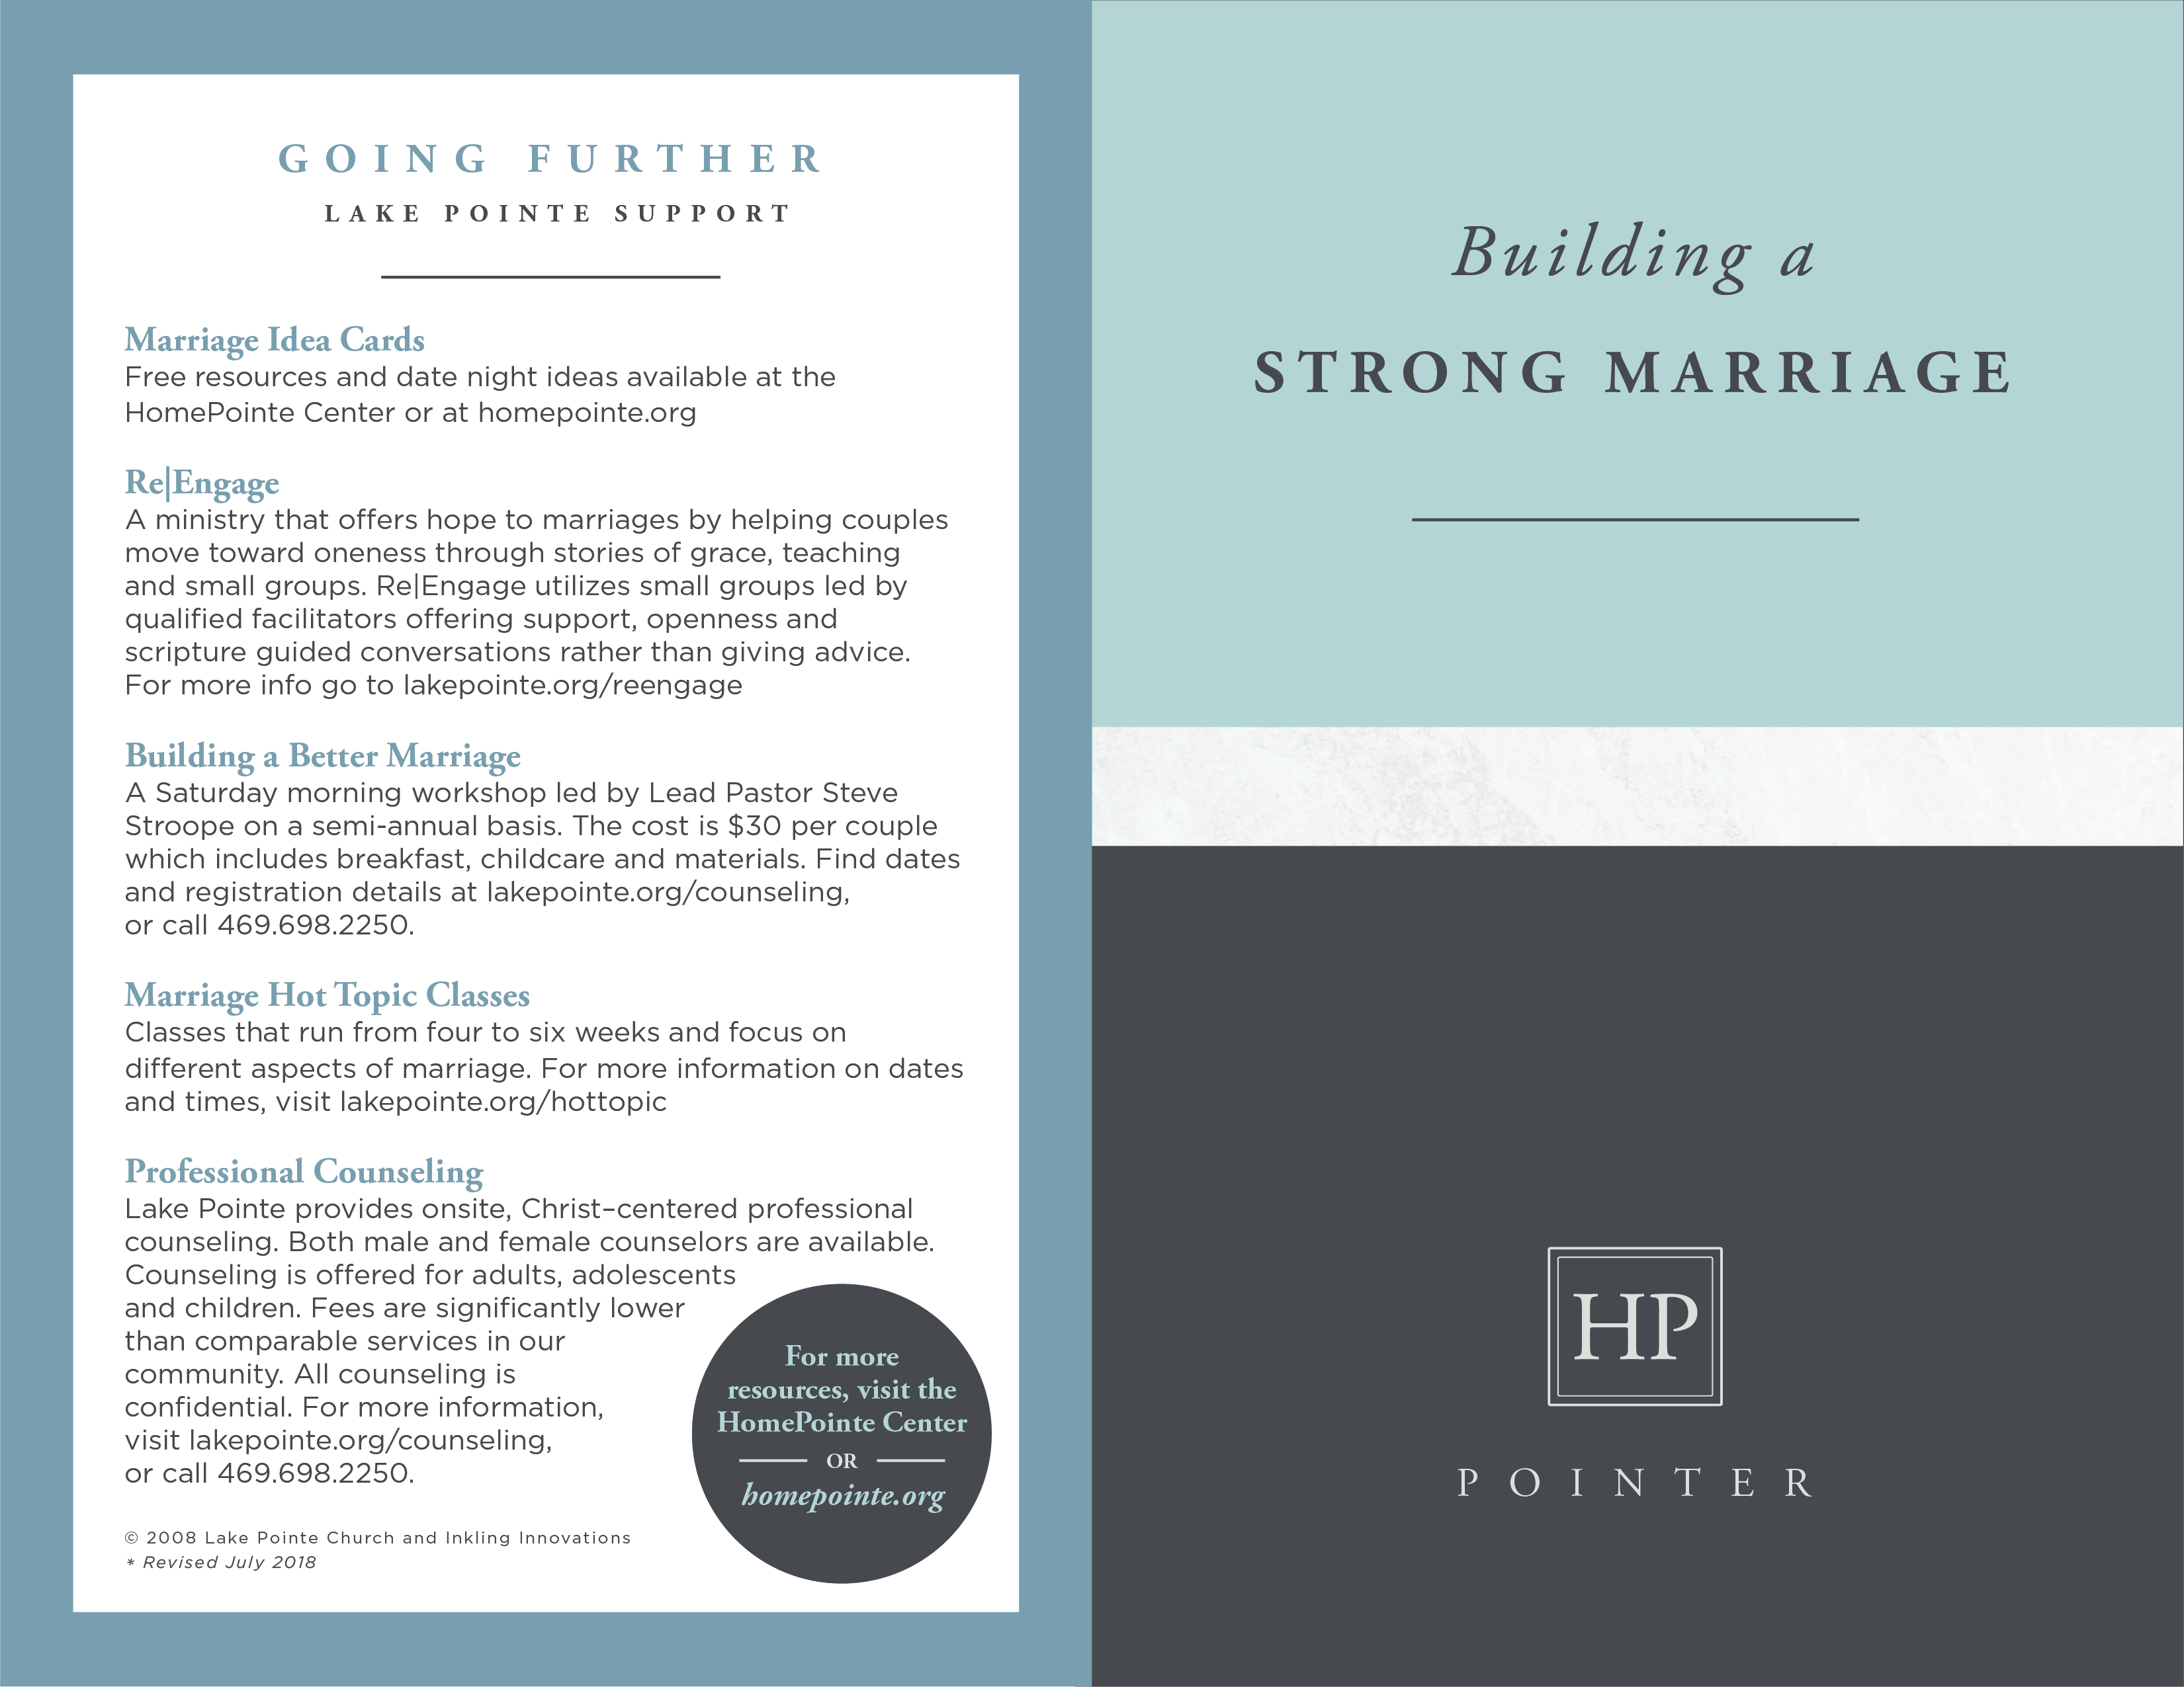

**GOING FURTHER**

**RESOURCES**

___________________

***The Handbook on Choosing Your Child’s Education: A***

***Personalized Plan for Every Age and Stage***

from Focus on the Family

Helps readers survey today’s educational choices and then make an informed decision about the best path for their children.

***Education a la Carte: Choosing the Best***

***Schooling Options for Your Child***

by Dr. Kevin Leman

Explains the pros and cons of various schooling options so that

parents can make an informed choice about the kind

of education that will help their child thrive.

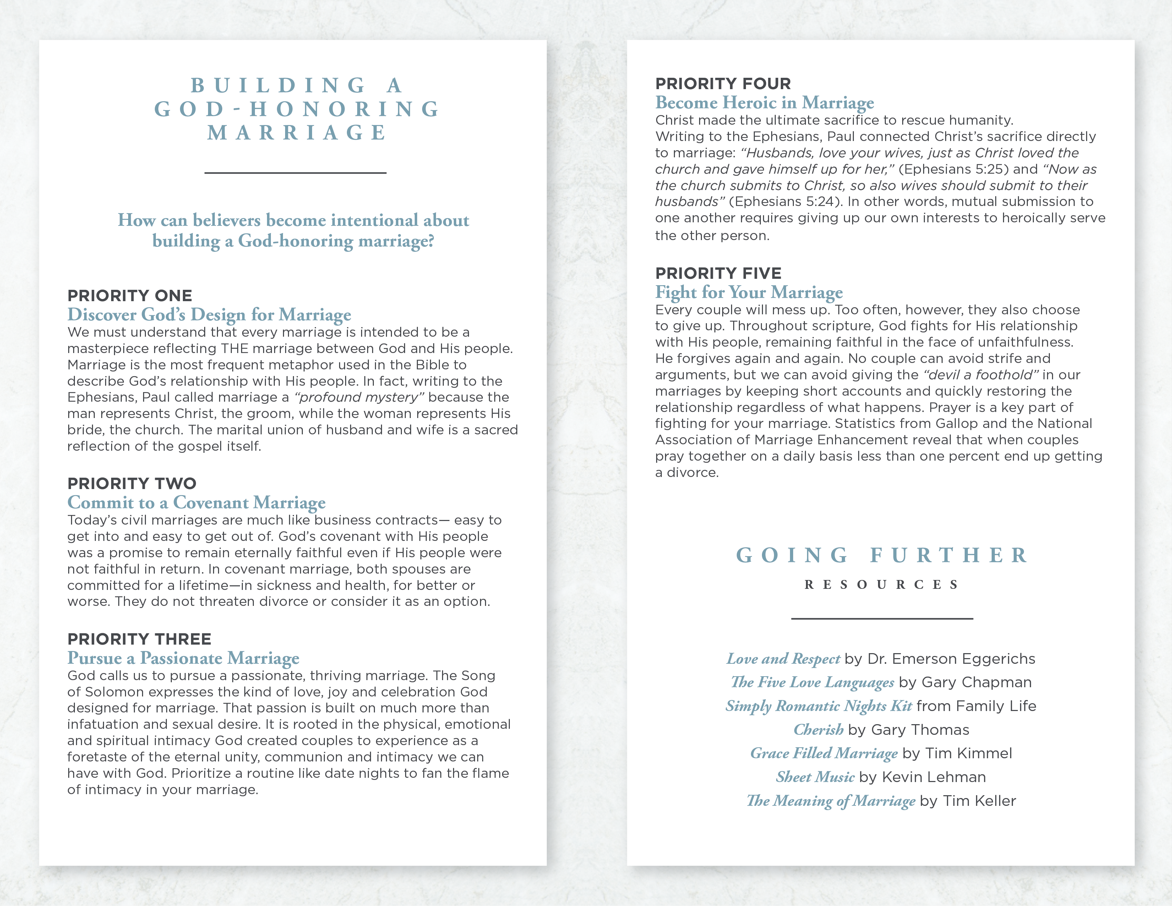

**YOUR CHILD’S**

**SCHOOLING**

**OPTIONS**

___________________

**Parents are the gatekeepers and ultimate decision makers for their children. As you evaluate the many schooling options available to your family, reflect on the following questions and apply prayer and Biblical wisdom to your educational choices.**

**QUESTION ONE**

**Who Has Ultimate Responsibility?**

Children are wired to observe and learn about all kinds of things in life - from friends, family, church, television and so on.

* **What is your role?**
* **What part do you play in what they learn and how they find their place in the world?**
* **Is one form of education better than another?**
* **Is your child okay in the public school?**
* **Is a private school or homeschooling better?**

The answer will vary from situation to situation. The most important thing to remember is that you have ultimate responsibility for the education of your child(ren). Deuteronomy 6:6-7 tells us:

*“These commandments that I give you today are*

*to be upon your hearts. Impress them on your children.*

*Talk about them when you sit at home and when you*

*walk along the road, when you lie down and when you get up.”*

We usually associate this verse with a child’s spiritual instruction, but the principle applies equally to character and academic training.

Parents have found value working with other people (including schools) to partner toward a strong education. Delegation does not remove the responsibility for oversight. It takes diligence to make sure those who partner with you in the education of your children reinforce rather than undermine your efforts.

**QUESTION TWO**

**What is Best for Each Child?**

Your oversight of each element of your child’s education should be coupled with an annual assessment of your child’s education needs. You should evaluate each child at the end of every school year for the following year. Commit to the plan that works best for your child for that year. Some parents move from one option to another based upon what they believe will best meet a child’s needs rather than feel “locked in” to any one approach. The same schooling option may not be the best for every child in the family.

**QUESTION THREE**

**How Do We Keep Faith a Priority?**

* **Everyone wants his or her child to succeed in life, but what does success look like?**
* **Does getting into a great college and then landing a dream job define success?**
* **Is it about being well-rounded with skills in a broad range of extracurricular activities?**

Too often, well-meaning parents seeking to give their children an edge for the future fill their schedules with activities that can squeeze out time for family and faith. Investment in family time that deepens the roots of faith, character and relationships which are foundational to real success in life.

**QUESTION FOUR**

**Who Can Give Advice and Guidance?**

It is always wise to ask those who have chosen different schooling options (including public, charter, online, private, home education, dual credit programs, etc.) for insights on the pros and cons of each. Since all of us tend to advocate the option we have chosen you may encounter those who seem to have a “one size fits all” perspective. Just listen and learn so that you can gain as much insight as possible as you prayerfully evaluate your own child’s situation.

© 2008 Inkling Innovations; Revised: 31-Jul-2018