*Sexual Identity*

**CONFUSION**

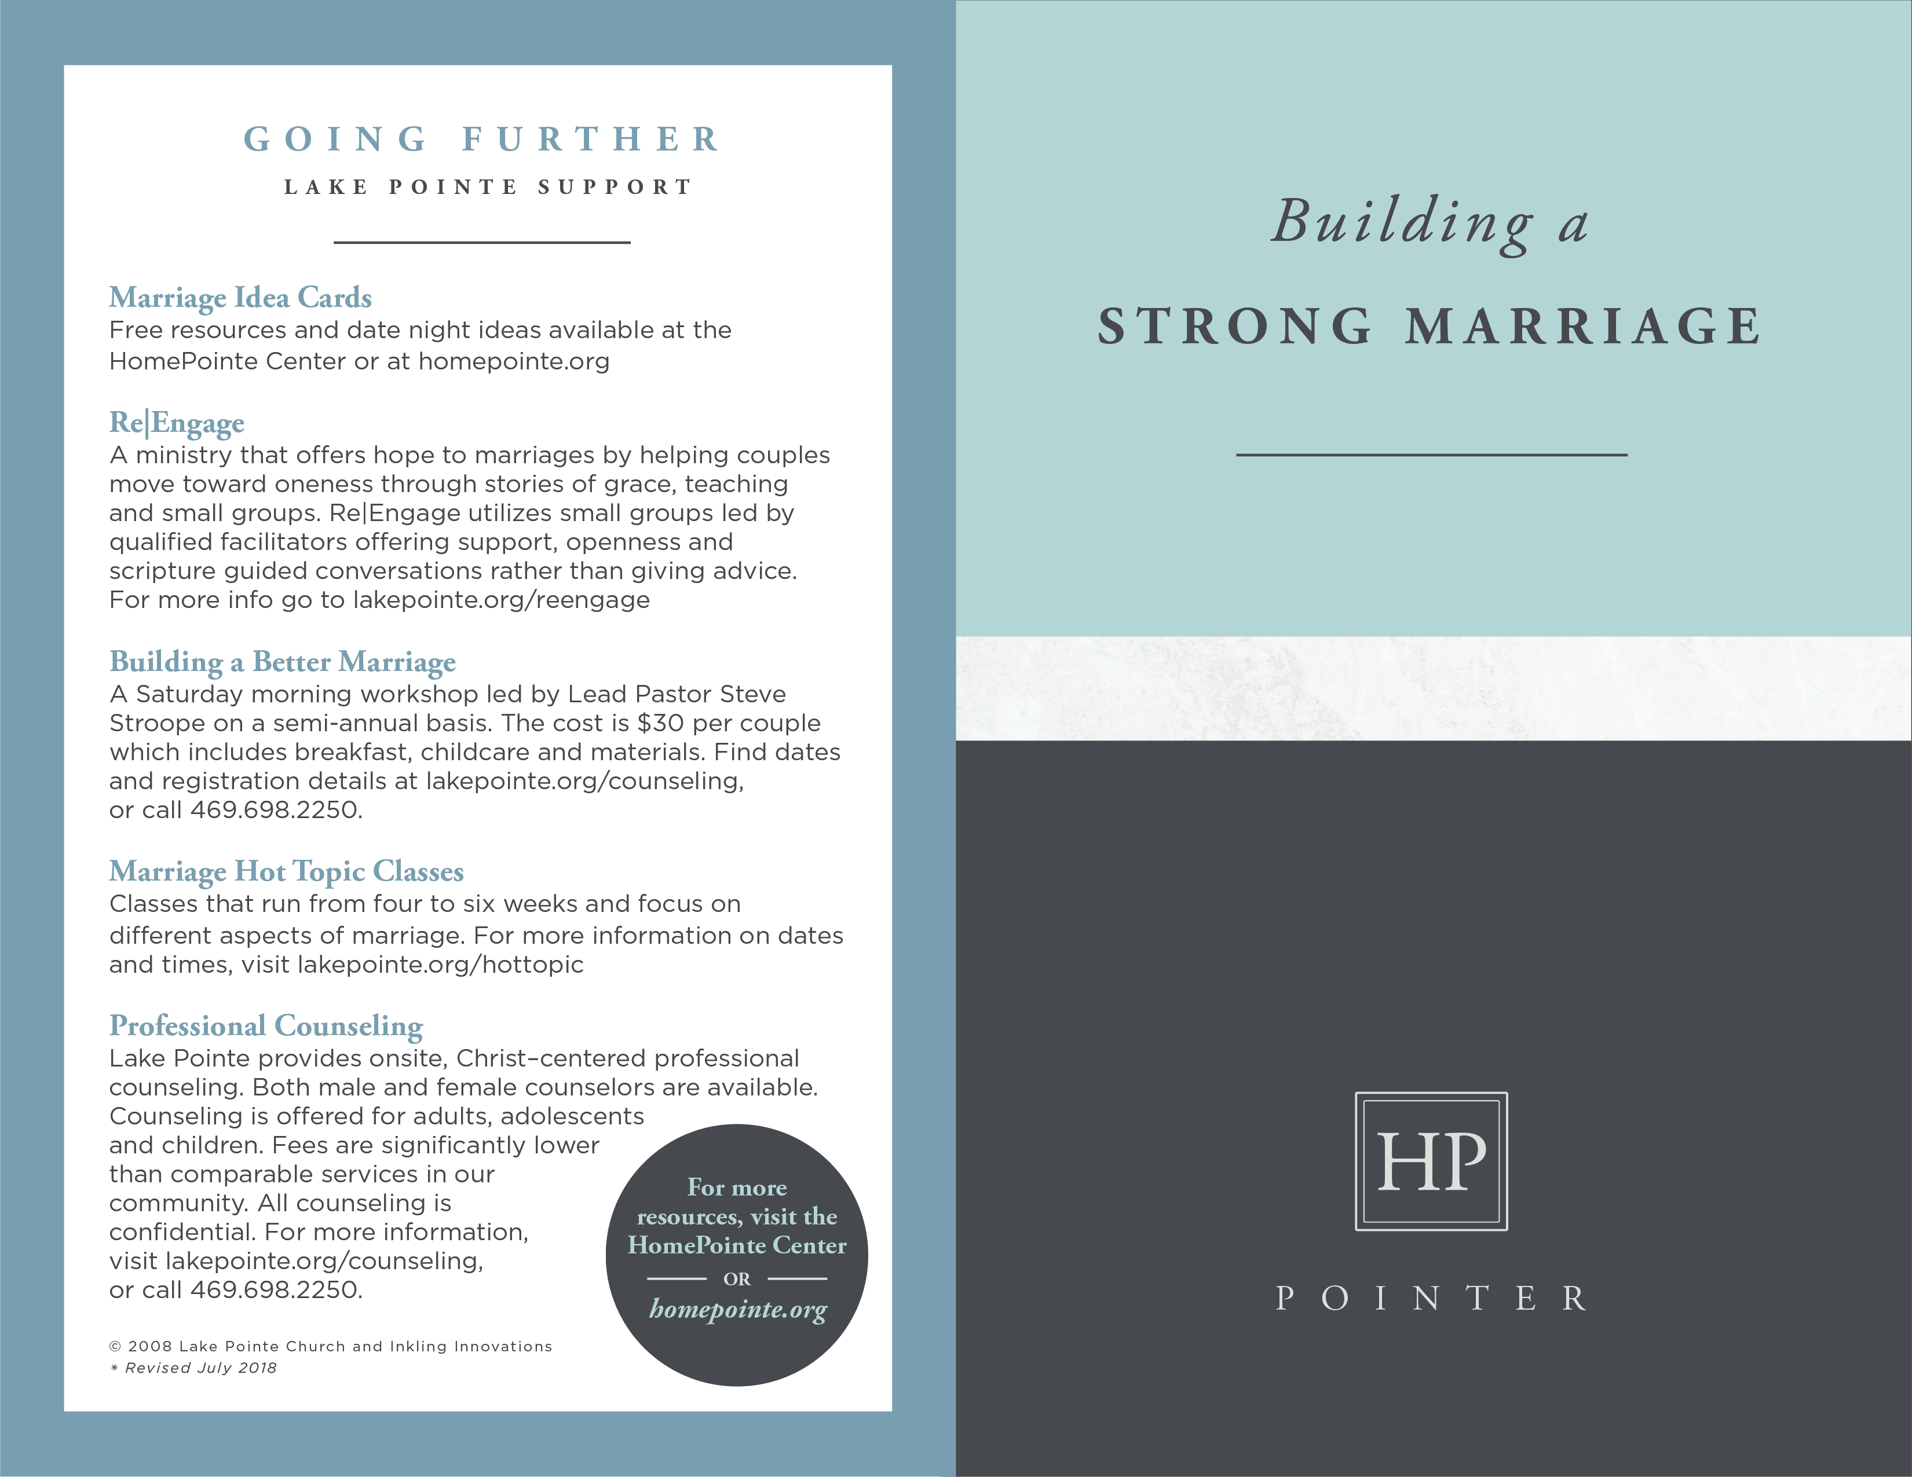

**GOING FURTHER**

**RESOURCES**

___________________

***Lovology: God. Love. Marriage. Sex. And the Never-Ending Story of Male and Female***

by John Mark Comer - Explores the meaning and implications of God’s design for human sexuality including tackling sensitive and challenging questions.

***Is God Anti-Gay?*** by Sam Allberry ***-*** Addresses why the gospel is good

news for those, like the author, who struggle with same-sex attraction.

***Restoring Sexual Identity:*** ***Hope for Women Who Struggle with Same-Sex Attraction*** by Anne Paulk ***-*** Offers practical advice for healing and change to women,

their families and friends wrestling with same-sex attraction.

***When Homosexuality Hits Home*** by Joe Dallas -Provides grace-filled, biblical perspective on same-sex attraction from those who have left the homosexual lifestyle.

***Living in a Gray World*** by Preston Sprinkle - Provides Christian teens

with a guide to understanding homosexuality.

***When Harry Became Sally: Responding to the Transgender Moment*** by Ryan T. Anderson - Addresses gender identity confusion and reassignment in light of the physiological realities to put recent cultural debates in perspective.

***LivingOut.org*** *-* A ministry that supports believers who experience same-sex attraction stay faithful to Biblical teaching on sexual ethics and flourish in their Christian walk.

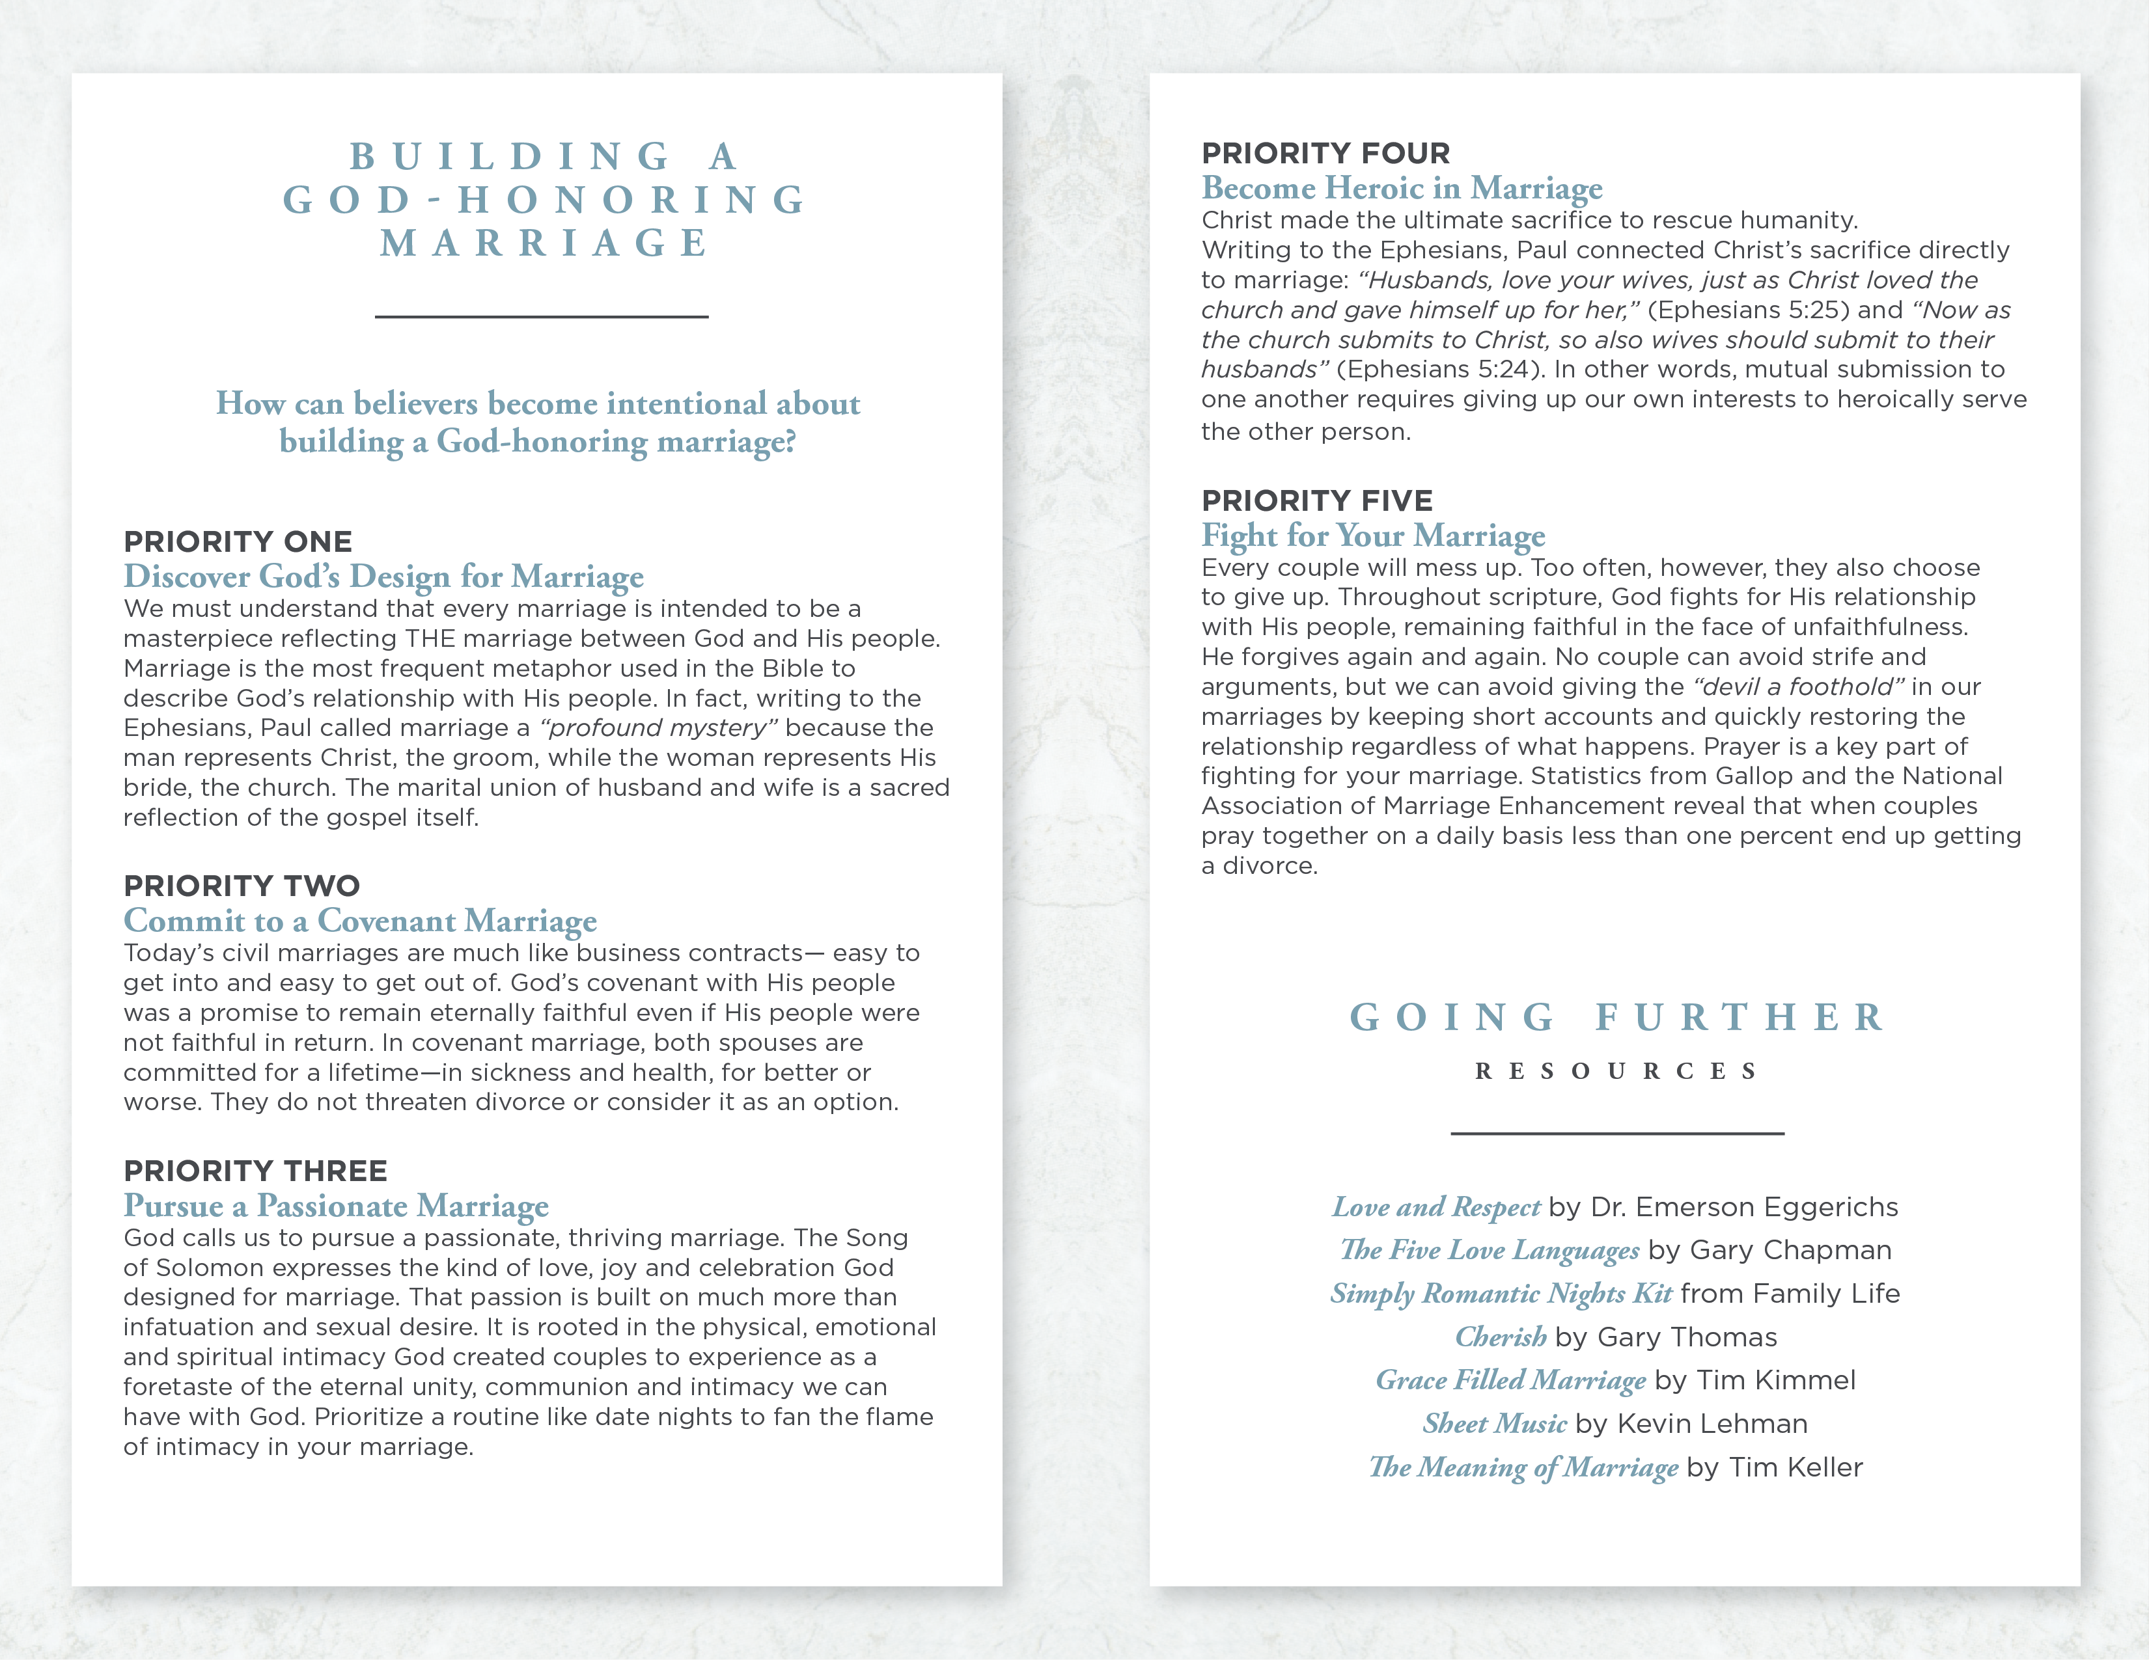

**SEXUAL/GENDER**

**IDENTITY**

**CONFUSION**

___________________

**Our generation is experiencing an increased level of**

**confusion with regard to sexual identity. When**

**addressing same-sex attraction, gender identity concerns,**

**or a transgender disposition we must approach such struggles with several foundational understandings.**

**Sexual Wholeness**

Wholeness begins with the realization that sex is first and foremost a noun (what we are) rather than a verb (what we do). Each of us has been created by God to reflect His image as male or female. *“Then God said, ‘Let us make man in our image, in our likeness’...So God created man in his own image, in the image of God he created him; male and female he created them. God blessed them and said to them, ‘Be fruitful and increase in number’”* (Genesis 1:26-28). Our physical design (male and female) points us to the nature of a triune God, an eternal communion of persons whose image we bear. Nothing reflects that image more than when two become one as husband and wife and enter into the intended design of conjugal love. Sexual health begins by understanding that our sex (male or female) is fixed in us at our creation and not a social construct or individual choice subject to alteration by the person created.

**Common Struggles**

Confusion over sexual identity can be common during puberty as an influx of hormones can throw the body and emotions out of balance.This is no time to panic. Under normal circumstances the confusion clears. However, those who are encouraged to act upon such short-term feelings can perpetuate and intensify the struggle into adulthood. Far too many adolescents listen to peers, the media and even authority figures pushing them to “come out” or declare themselves to be something other than what God made them to be. This can trap them in the mistaken idea that one’s desires (even if short-term) dictate one’s identity.

Christianity recognizes that human affections can become disoriented due to the effects of the fall. As the Apostle Paul wrote in his letter to the

church at Rome, “We know that the law is spiritual; but I am unspiritual, sold as a slave to sin…For what I want to do I do not do, but what I hate I do” (Romans 7:14-15). Every person feels desires that run counter to our intended design including a variety of sexual struggles like pornography addiction, same-sex attraction and others.

**A Redemptive Approach**

The emotions associated with same sex attraction and gender identity confusion are both real and complex. Many individuals desperately wish they could free themselves from feelings and desires that can make them feel abnormal or even shame. Unfortunately, extending hope in such situations has become difficult because those who affirm God’s design for human sexuality are labeled “bigots” or “homophobic haters” by those with a political agenda. Loved ones and friends are told that if you don’t accept the person’s lifestyle choices you are rejecting them as a person. Christians should love others too much to perpetuate lies that undermine sexual wholeness. To become agents of redemption in the midst of an increasingly emotional debate, both the person wrestling with sexual identity confusion and the person who cares about them can follow a few important steps.

* **Step One: Extend Grace**

Refuse to perpetuate stereotypes. Not everyone struggling with same-sex attraction is living in rebellion against God’s design.  On the other side, those who believe God intended sexual union exclusively for a husband and a wife are motivated by truth and love, not ignorance or hate. So extend grace. Give one another permission to disagree without calling names or assuming the worst.

* **Step Two: Explore God’s Design**

Regardless of our current posture or perspective, the best starting place is to explore what it means to be created male and female in God’s image and how we can find sexual wholeness as intended by our Creator. Start with resources suggested in the Going Further section.

* **Step Three: Glean From Those Who Understand**

Same-sex attraction and sexual identity confusion are complicated matters with no easy answers. The journey to wholeness may be a difficult, long process. Seek wisdom from those who have been where you are. Let them help you discover the joy and health that comes from pursuing God’s loving, beautiful design for human sexuality. Start by exploring the *Going Further Resources*.

© 2008 Inkling Innovations; Revised: 15-Dec-2018