**SEXUAL INTIMACY**

*Finding Fulfillment*

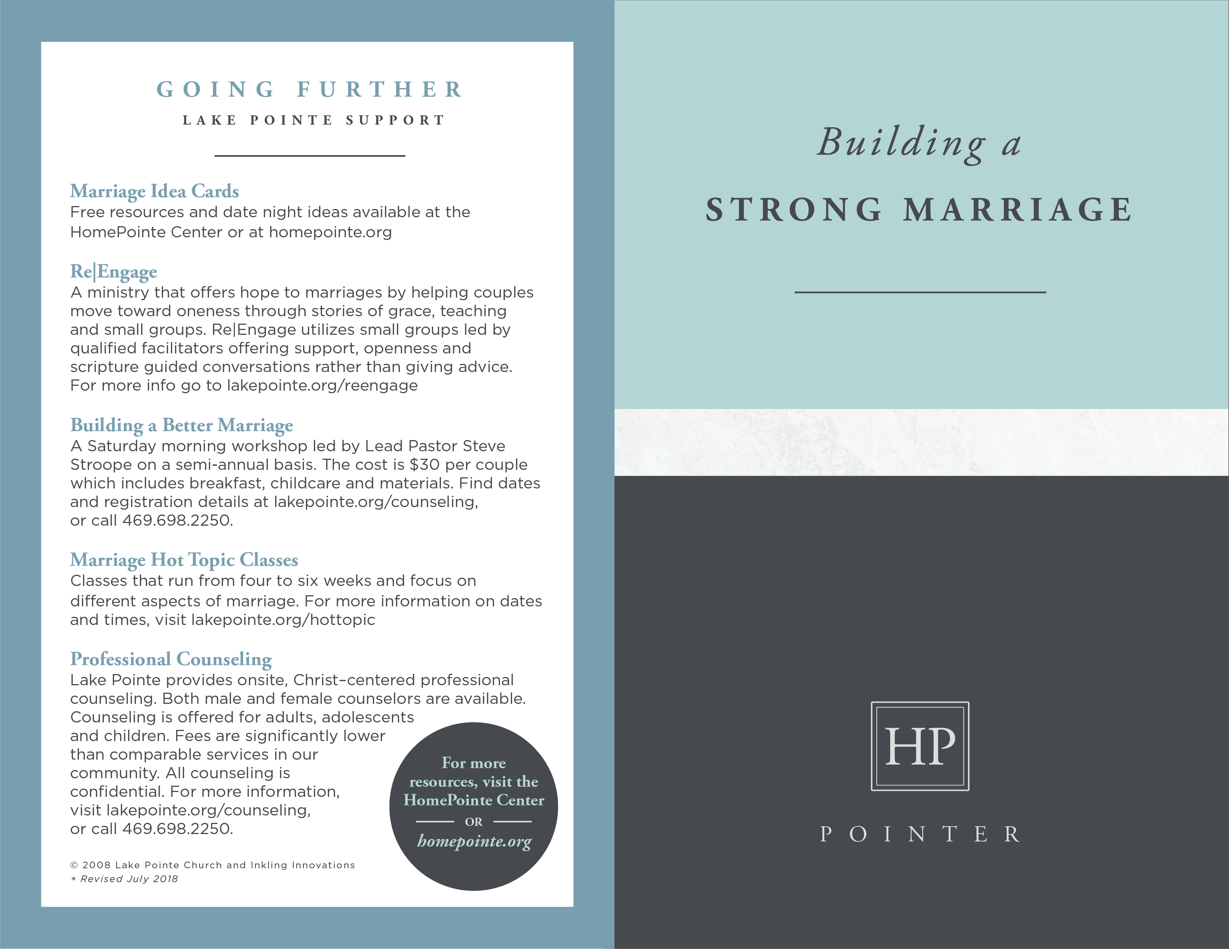

**GOING FURTHER**

**RESOURCES**

___________________

***Lovology: God. Love. Marriage. Sex. And the Never-Ending Story of Male and Female*** by John Mark Comer

Gives a biblical vision for sexual intimacy and marriage and tackles difficult questions related to human sexuality.

***Have a New Sex Life by Friday*** by Kevin Leman

Encourages married couples to pursue the joys and pleasures of sexual intimacy.

***Intimate Issues*** by Linda Dillow and Lorraine Pintus

Answers common questions from women.

***Every Man’s Battle and Every Woman’s Battle*** by Stephen Arterburn

Provide advice on dealing with sexual temptations such as pornography.



**SEXUAL INTIMACY –**

**FINDING FULFILLMENT**

___________________

God created us as sexual beings designed for physical intimacy. The scriptures teach that each of us has been made in the image of God either male or female. *“In the image of God he created them; male and female he created them.”* (Genesis 1:27) Grasping this reality is the foundation of sexual fulfillment no matter what life season you find yourself in, from a young person anticipating the wonders of romantic love to a married couple seasoned in the beauty and excitement of erotic pleasures.

**What We Want**

Many Christians spend their lives yearning for a sexual intimacy they never experience for various reasons including…

* **Temptation:** God gave us a sex drive to be heeded and enjoyed in its proper time and place. As fallen creatures we experience the ongoing temptation to pursue physical gratification for its own sake, a reality made more difficult in a culture that bombards us with images and messages that can warp and undermine lasting sexual fulfillment.
* **Deception:** From an early age we are fed lies about sex. Puritanical rigidity says sex is dirty. The sexual revolution overreacted by swinging to the other extreme, telling us we have a right to sexual gratification by whatever means. Gender identity politics tells young people they can choose their sex rather than celebrate it as a fixed, physical reality given by a God who doesn’t make mistakes.
* **Exploitation:** Sexual abuse and exploitation robs those impacted of the capacity to enjoy God’s intended design for physical intimacy. Those who have endured such experiences need God’s grace and healing so that they can enter into a healthy, proper sexual relationship.
* **Dysfunction:** Temptation, deception and exploitation all feed dysfunctional dynamics between husband and wife that can undermine a healthy, happy sex life.

**What We Were Made For**

C.S. Lewis said that we are far too easily pleased, “like an ignorant child who wants to go on making mud pies in a slum because he cannot imagine what is meant by the offer of a holiday at the sea.” This is certainly true in the area of sexual fulfillment. Too often we seek satisfaction in ways that fall far short of the pleasures and joys that come with God’s design for physical intimacy.

* **The Mystery:** In Ephesians 5:31-33 the scriptures tell us that marital intimacy is a mysterious picture of the relationship between Christ and His bride, the church. When we give ourselves to one another in marriage we reflect the Gospel in ways we can’t comprehend but sense in our most fulfilling moments.
* **The Design:** Each of us has a complete respiratory system, a digestive system and nervous system. But our bodies only consist of one-half of a reproductive system. That’s because God made us male and female as complimentary parts of the image of God. It is no accident that the first command given those God made “in the image of God…male and female” was to “be fruitful and multiply.” (Genesis 1:28) Our bodies have a wonderful design stamped into us at creation that can only be fully experienced through the mystery of marriage.

* **The Act:** We yearn for a mate because we are designed for intimate communion with the opposite sex. It is also no surprise that the only thing God called “not good” after creation was a man without a woman. That is because we are made in the image of the Trinity, a loving communion of persons who gives most of us the amazing privilege of participating in the process of creating more in His image!

**Finding Fulfillment**

God invented sex and smiles upon intimate acts that are mutually satisfying to married couples. Husbands and wives that willingly give themselves to one another in order to meet their spouse’s needs and desires (rather than merely satisfy their own) will enter into one of life’s most exciting and beautiful experiences. To achieve this type of fulfillment requires replacing lies with truth including…

* **Sacred vs. Sinful:** Sex is not a naughty, hidden sin to regret but a thrilling, exclusive secret to share. Scriptures such as Song of Solomon 4:16-5:1 celebrate the pleasures of what happens in the private moments between husband and wife. In other words, couples should enjoy one another to the fullest!
* **Gift vs. Gratify:** Physical intimacy is not an obligation to endure but a gift to enjoy. It is not something we demand for personal gratification but something we give for marital fulfillment.
* **Wait vs.** **Waste:** The intensity of sexual pleasure increases when reserved for the exclusive domain of the marriage bed. It diminishes when wasted on casual, short-term relationships that fall outside God’s design.

© 2008 Inkling Innovations; Revised: 15-Dec-2018