*Married To An*

**UNBELIEVING SPOUSE**

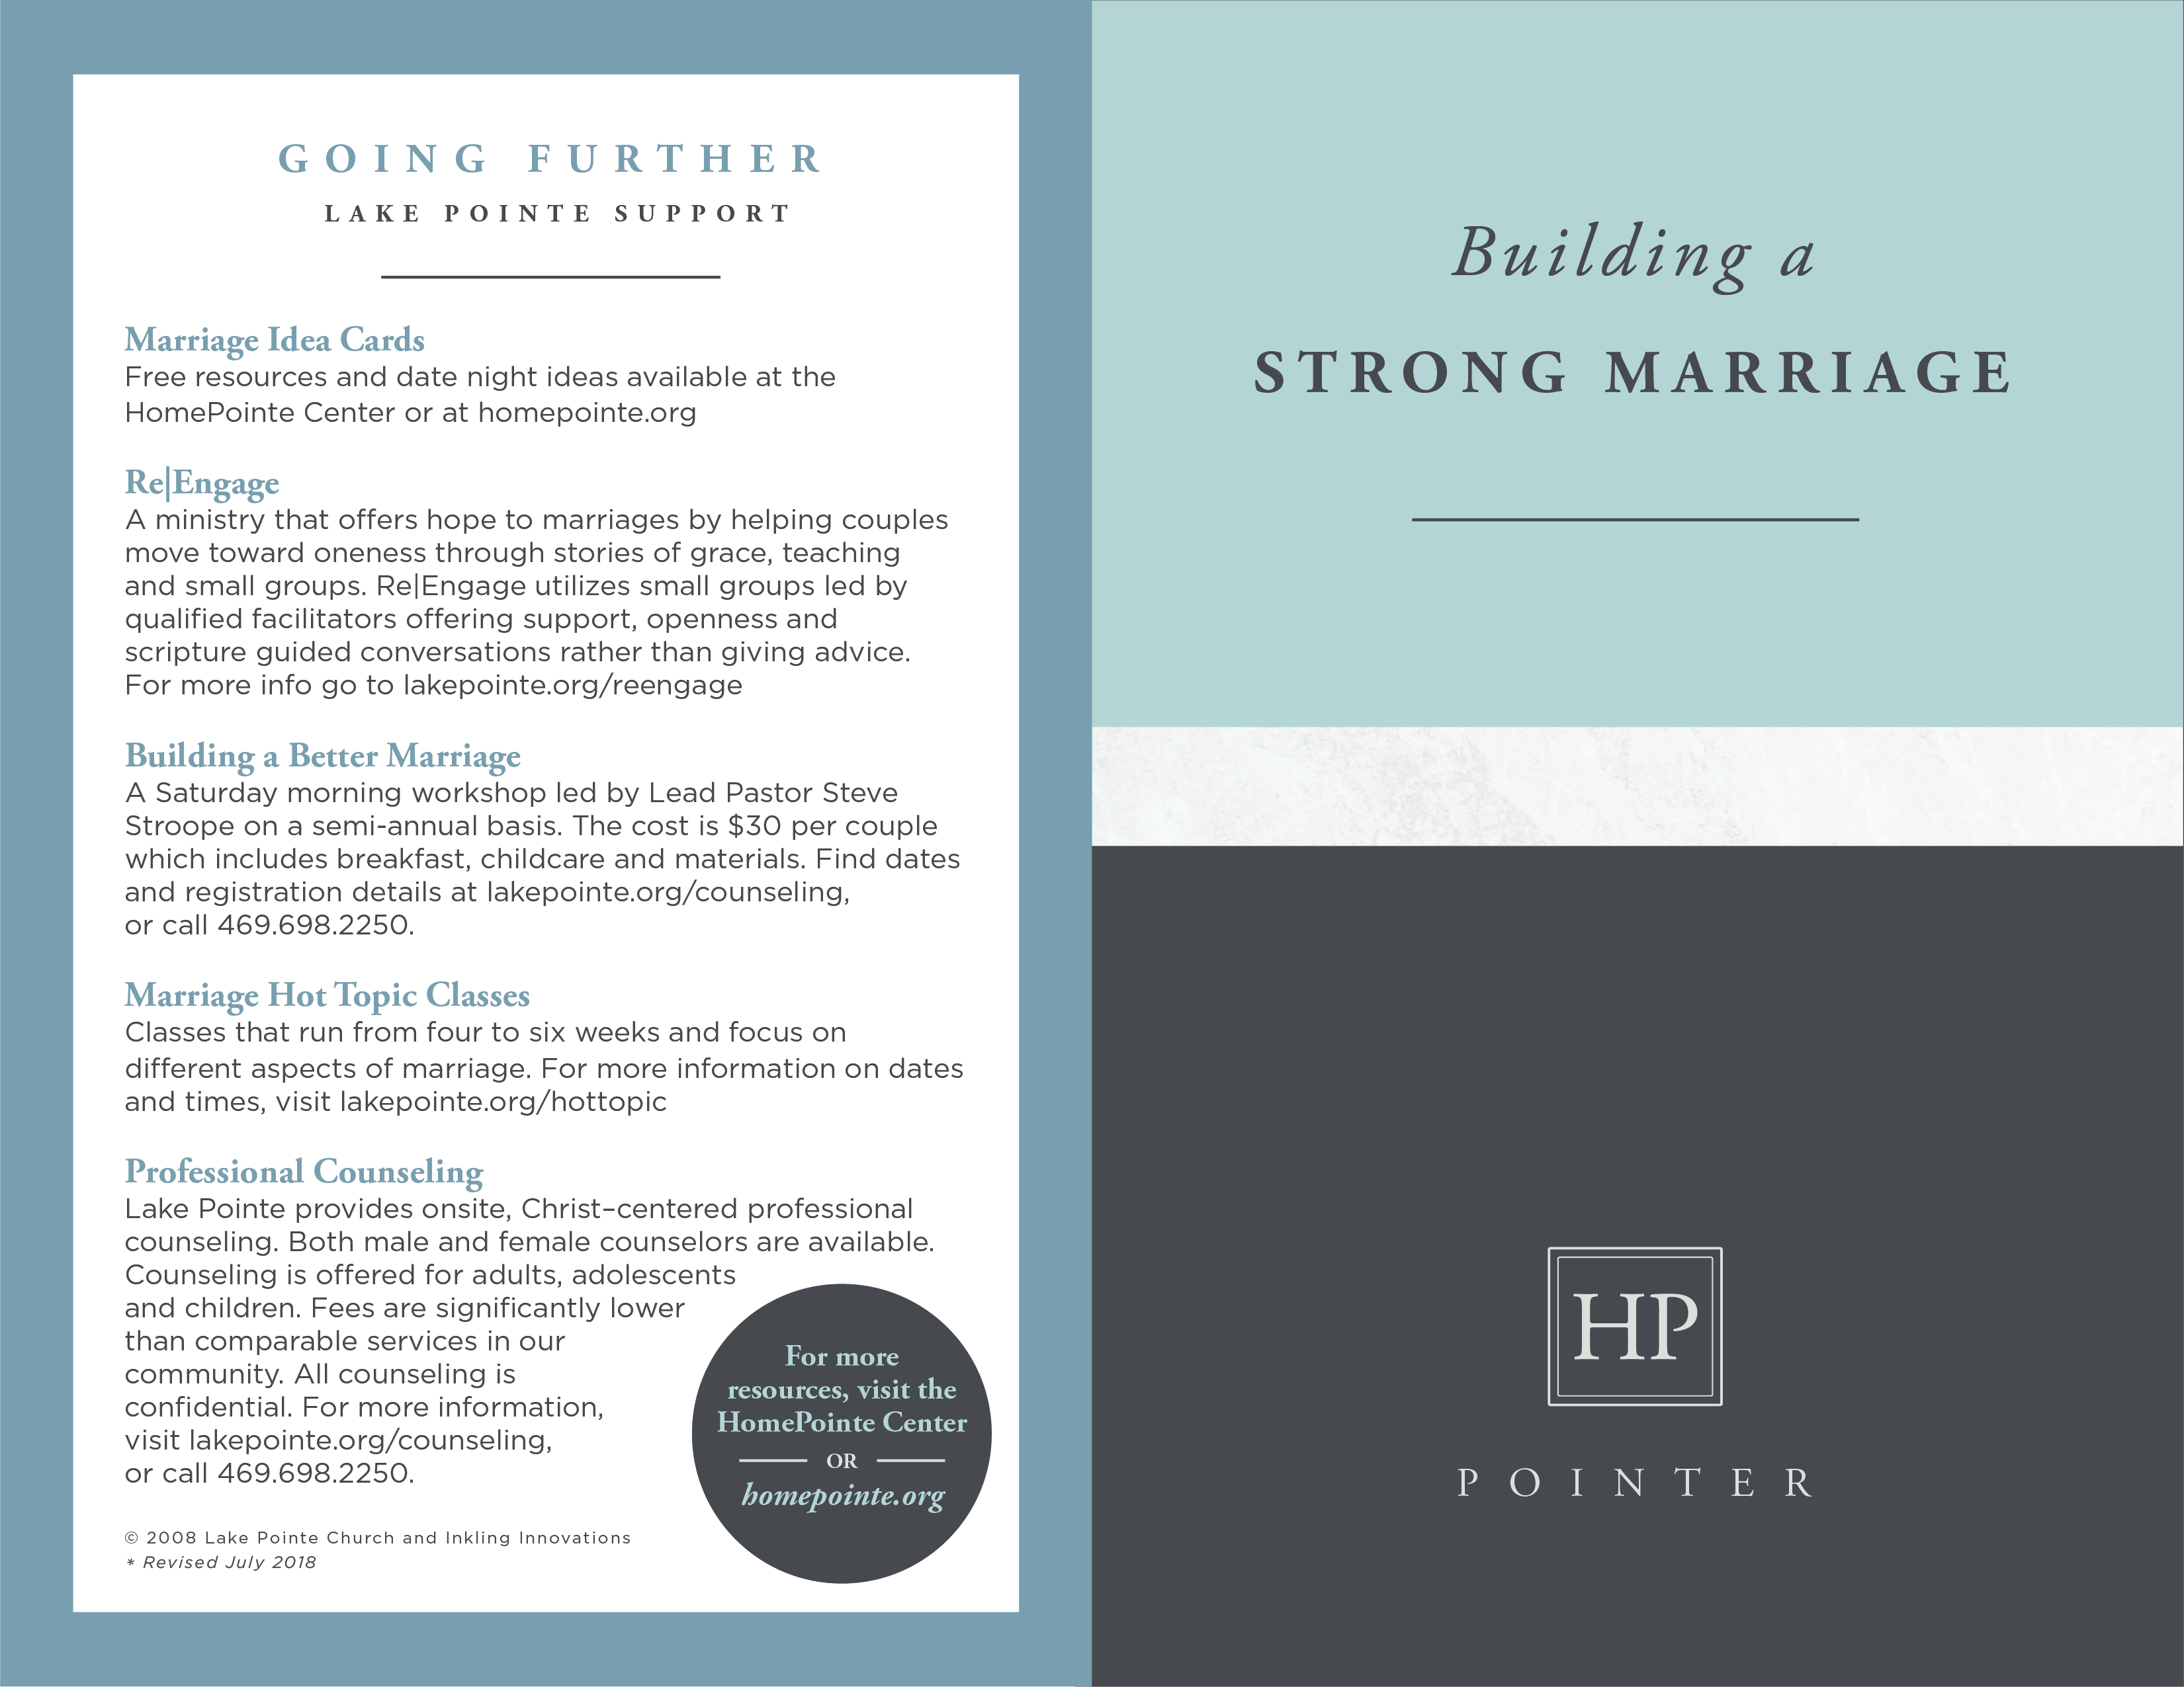

**GOING FURTHER**

**RESOURCES**

___________________

***Beloved Unbeliever: Loving Your Husband into the Faith***

by Jo Barry

Offers positive ways to approach the problem of being unequally yoked.

***Spiritual Mismatch: Hope for Christians Married***

***to Someone Who Doesn’t Know God***

by Lee Strobel & Leslie Strobel

Provides hope for Christians married to an unbelieving spouse.

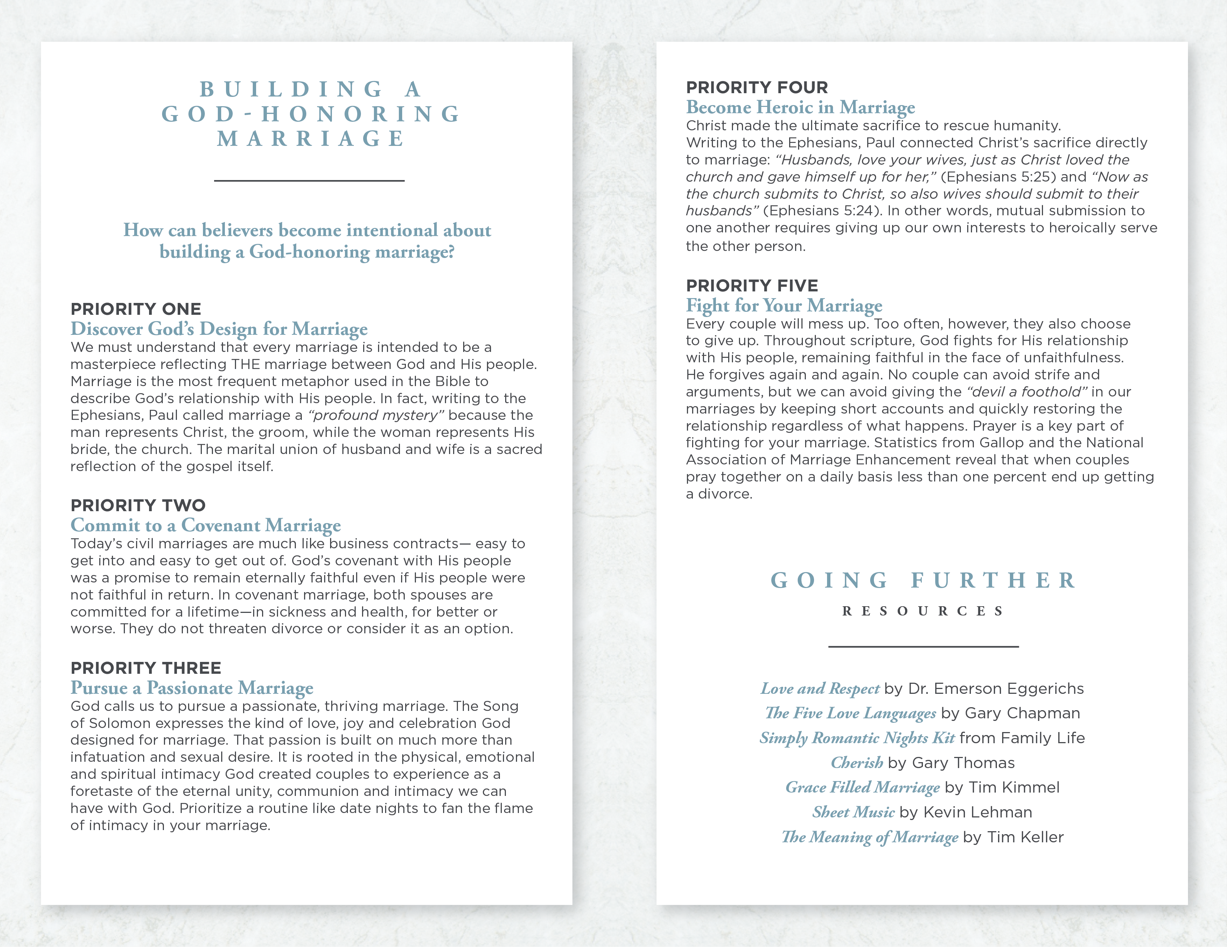

**FOLLOWING**

**CHRIST**

**ALONE**

___________________

Growing in intimate relationship with Jesus Christ is a source of great joy. It can be a source of conflict when your spouse doesn’t share your commitment to Christ. It makes it more difficult to face life challenges, to make important decisions and even to grow in your faith when you are not both centering your life on God’s will.

Even when your spouse is basically a good person, the disconnect of no shared faith in Christ or worrying about where your spouse will go after death can hurt your relationship. It’s even worse if your spouse is hostile to your faith.

**How can you honor God when your spouse**

**doesn’t? Is there anything you can do to help**

**your spouse become a believer?**

**Be with Believers – But Not Too Much**

Christianity is a group faith - something to be lived out among a community of believers. As a body of people following Christ, we give and receive fellowship, comfort, and encouragement (1 Corinthians 12:12:27, Galatians 6:2, Philippians 2:4, 2 Corinthians 1:3-4). You need that community of believers, especially others who are following Christ alone in their marriages. But your spouse needs you as well. God designed marriage to be a source of mutual support. You are accountable to the vows you made to your spouse even if he or she is not a believer. To honor both your marital vows and your place in the body of believers, you should commit to regular church involvement that still leaves quality time to invest in your marriage. There’s a better chance your spouse will come to faith if you make time to go to church and he(she) sees that God now has priority in your life and has changed you. But if you join every Bible study and volunteer for a broad range of extra activities, it can give the signal that you are no longer committed to meeting the needs of your spouse - especially if you’re doing those things to keep yourself occupied apart from your spouse.

**Let Your Actions Be Your Witness**

If you are balancing your involvement in a body of believers with your involvement in your marriage, what can you say to help your spouse become a believer? What really influences a spouse more than your words are your actions. To wives of unbelievers, the Apostle Peter said:

*“Wives, in the same way be submissive to your*

*husbands so that, if any of them do not believe the word,*

*they may be won over without words by the behavior*

*of their wives when they see the purity and*

*reverence of your lives” (1 Peter 3:1-2).*

No amount of nagging or persuading can motivate an unbelieving spouse toward faith. It might even drive him(her) further away. The best draw will be seeing you live out your faith by showing your spouse respect and loving care like he(she) never seen before. It won’t be easy and there’s no guarantee that it will generate an immediate response. If you choose to love your spouse as unto the Lord, regardless of how he(she) responds, you can leave the rest up to God, knowing you were faithful.

**Maintain a Hopeful Perspective**

When you are growing within a body of believers and faithfully seeking to serve and esteem your spouse, you can be hopeful. You can’t control the timing, but you can believe that God is able to use your commitment to win over even the most reluctant spouse. Pray for strength as you point your spouse to Christ and for his(her) heart to be softened and drawn to Him.

© 2008 Inkling Innovations; Revised: 31-Jul-2018